**assignment #2 : 14th January 2024**

**Assignment Q1: How to manage SSH and RDP Configuration:**

**Describe the Steps involved in configuring SSH on the Linux EC2 instance and RDP (Remote Desktop Protocol) on the Windows EC2 instance to allow cross-platform connectivity.**

**Step 1: Click on “Edit” in “Network Settings”.**

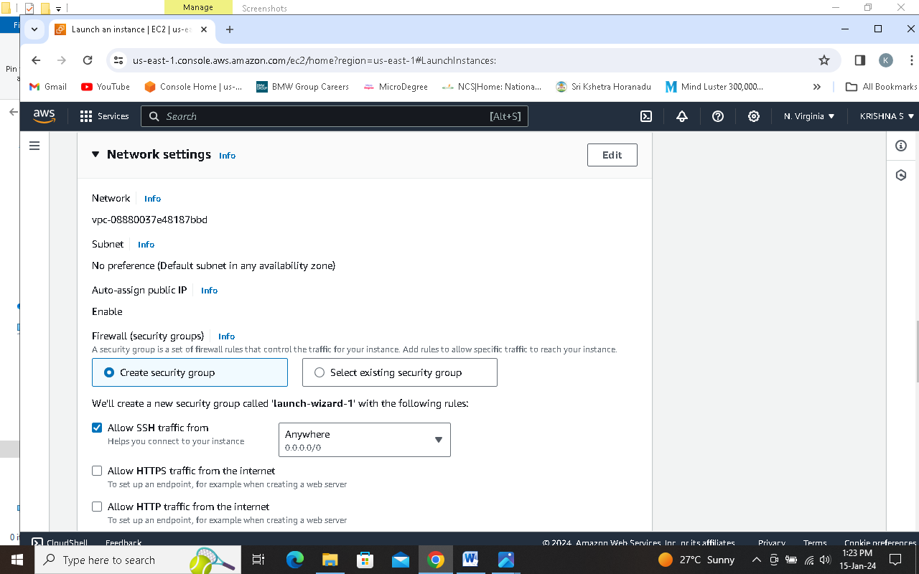

**Step 2: Rename the Security Group as you want**

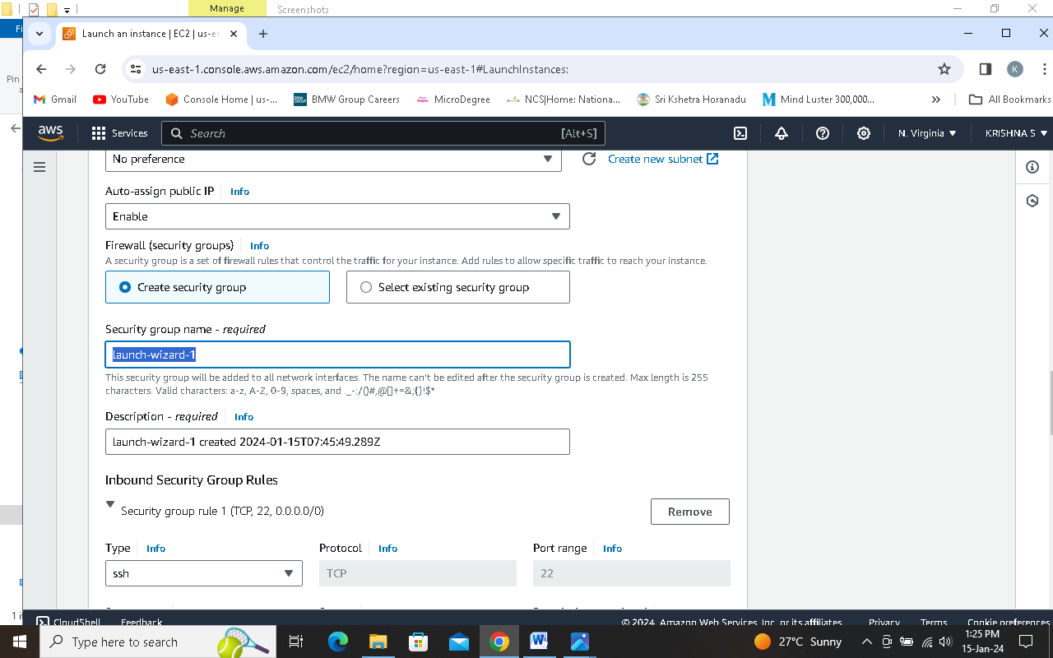

**Step 3: Click on “Add security group rule”.**

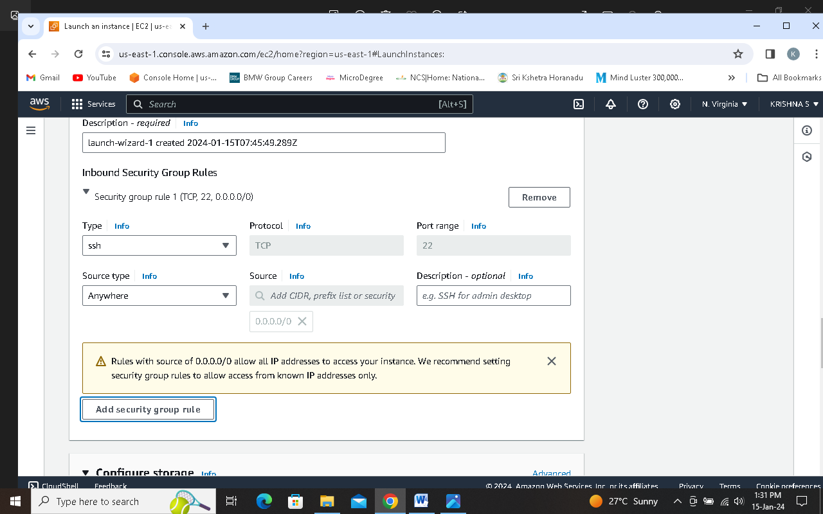

**Step 4: Select “Http” in “Type” dropdown list.**

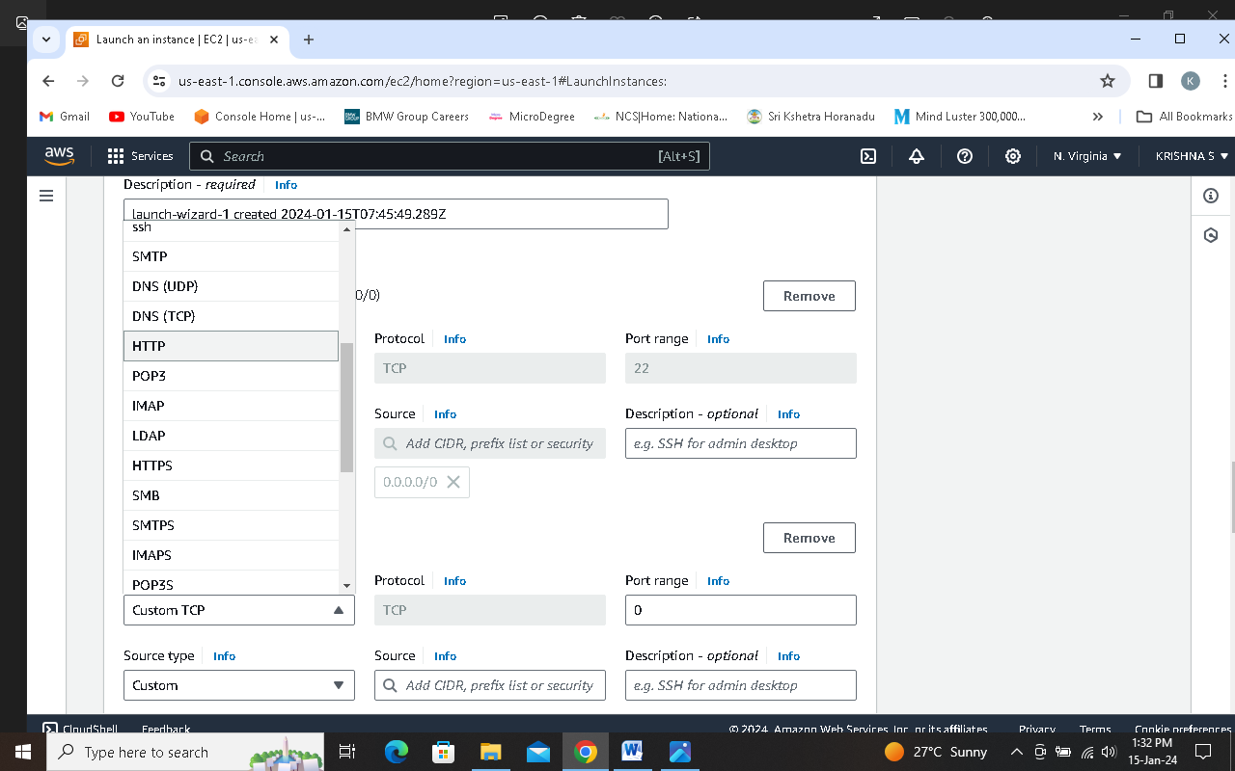

**Step 5: Select Anywhere in Source type dropdown list.**

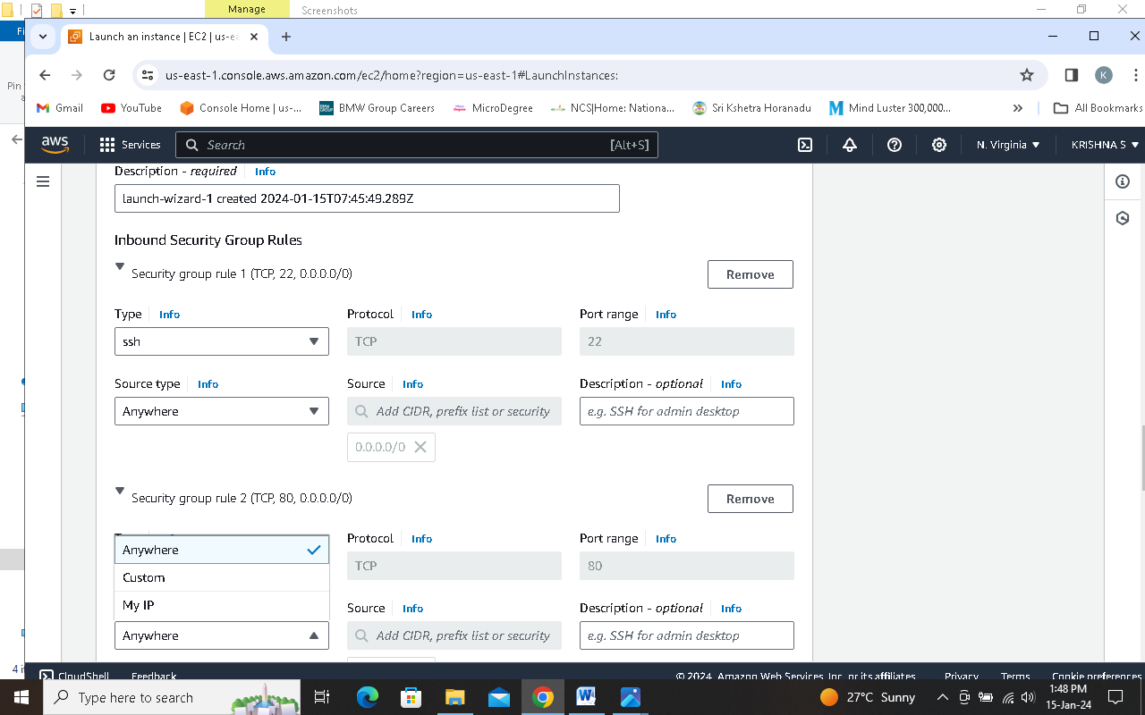

**Step 6: Click on Launch Instance**

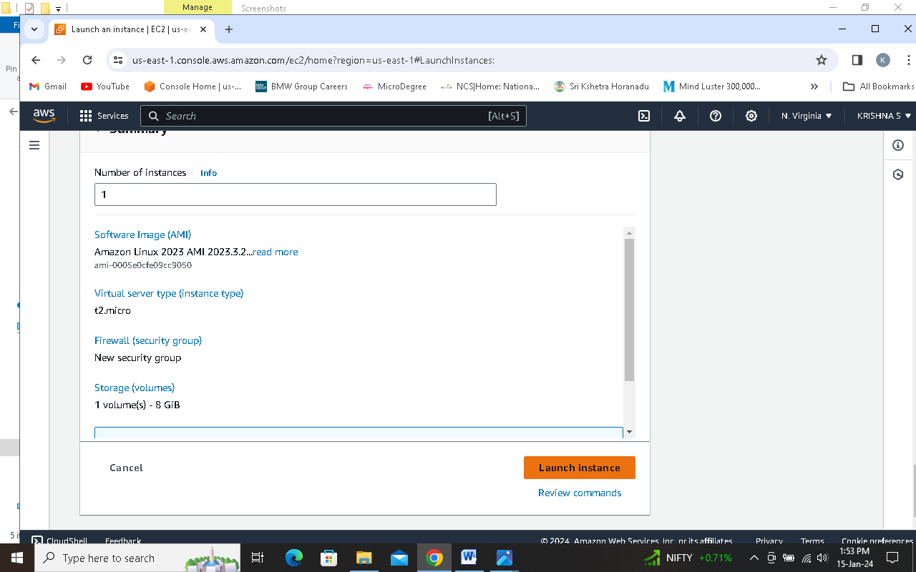

**Step 7: Successfully launched an instance**

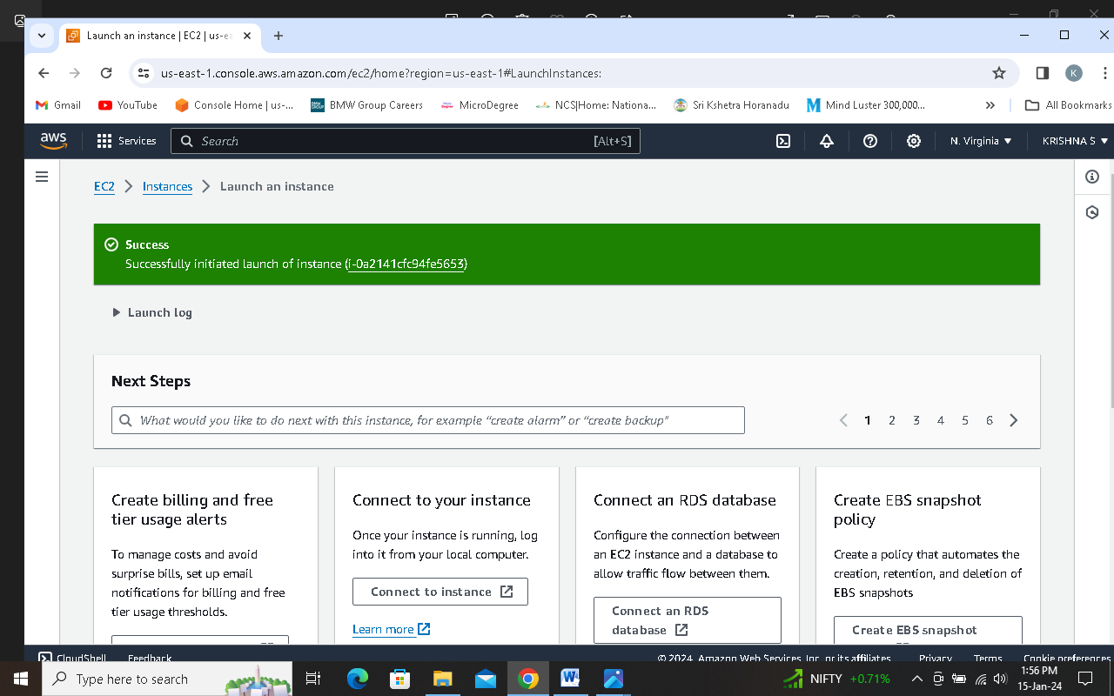

**Step 8: Confirm that status check passed**

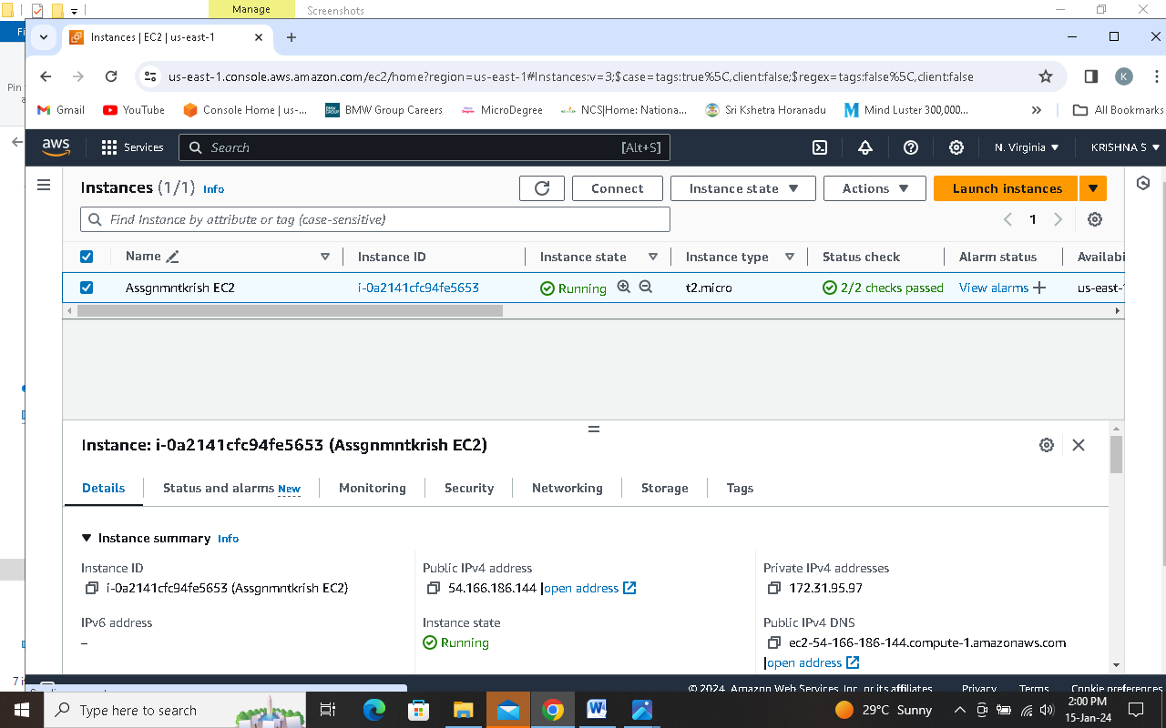

**Step 9: copy the public IPv4 address**

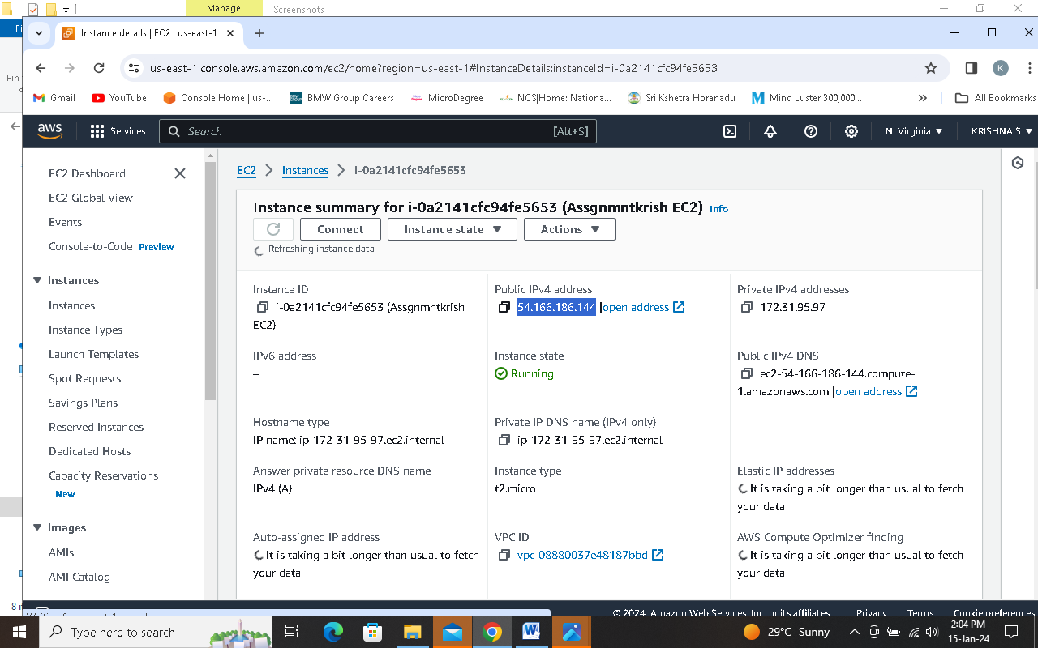

**Step 10: open “putty app” from start menu**

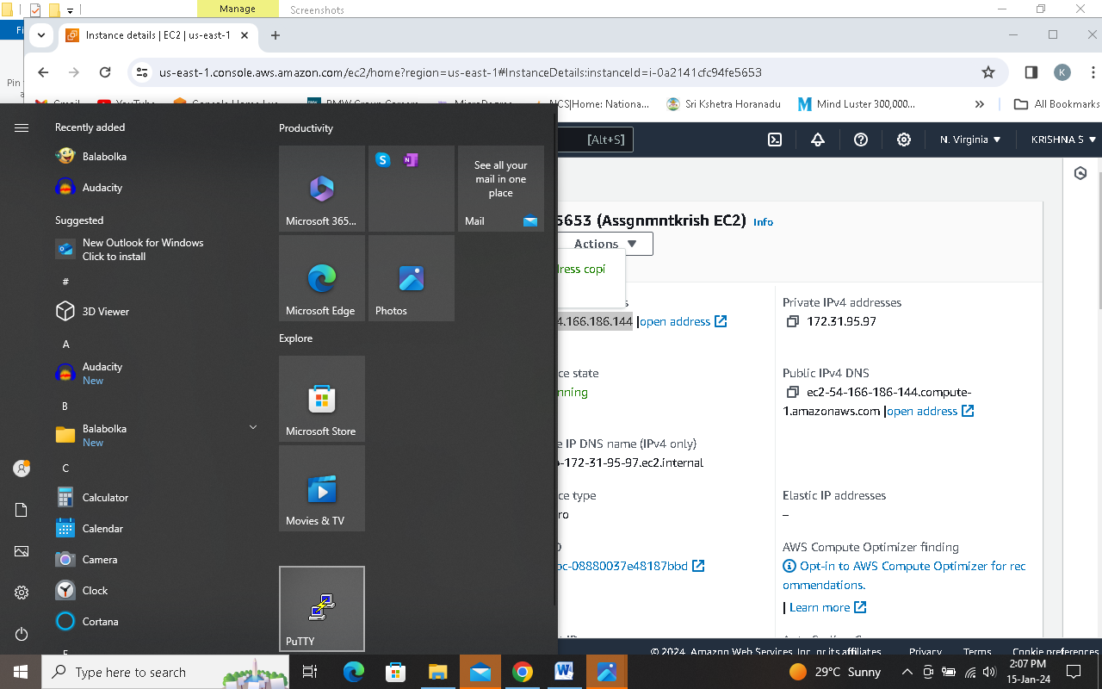

**Step 11: paste the copied Public IPV4 address in Host name then click on SSH > Auth > Credentials**

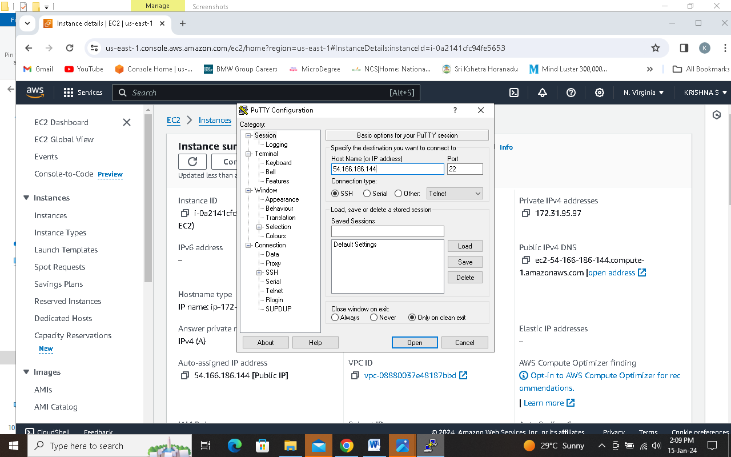

**Step 12: click on browse to select Private Key which is downloaded while creating instance.**

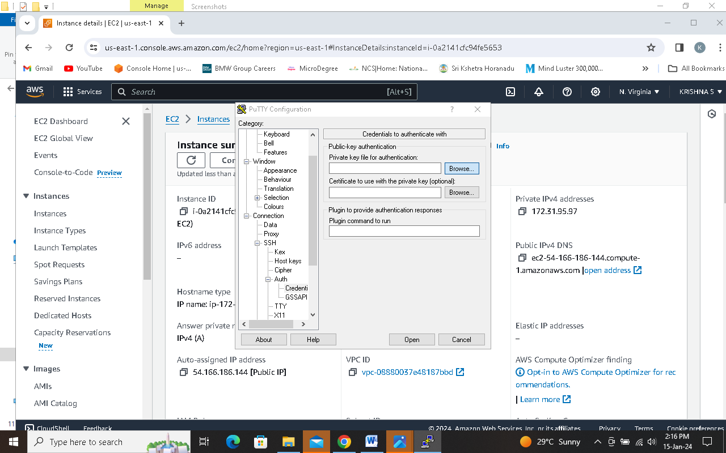

**Step 13: Select the downloaded ppk file then press open**

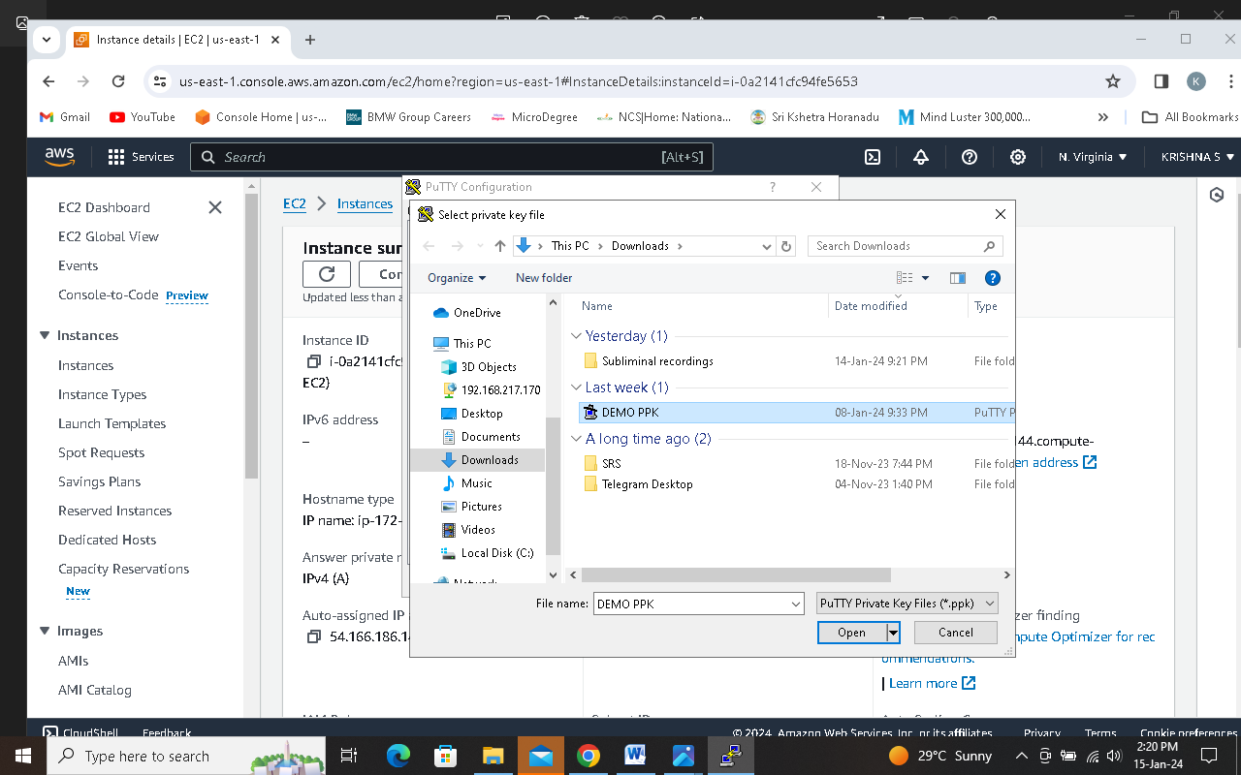

**Step 14: Error due to low internet connection.**

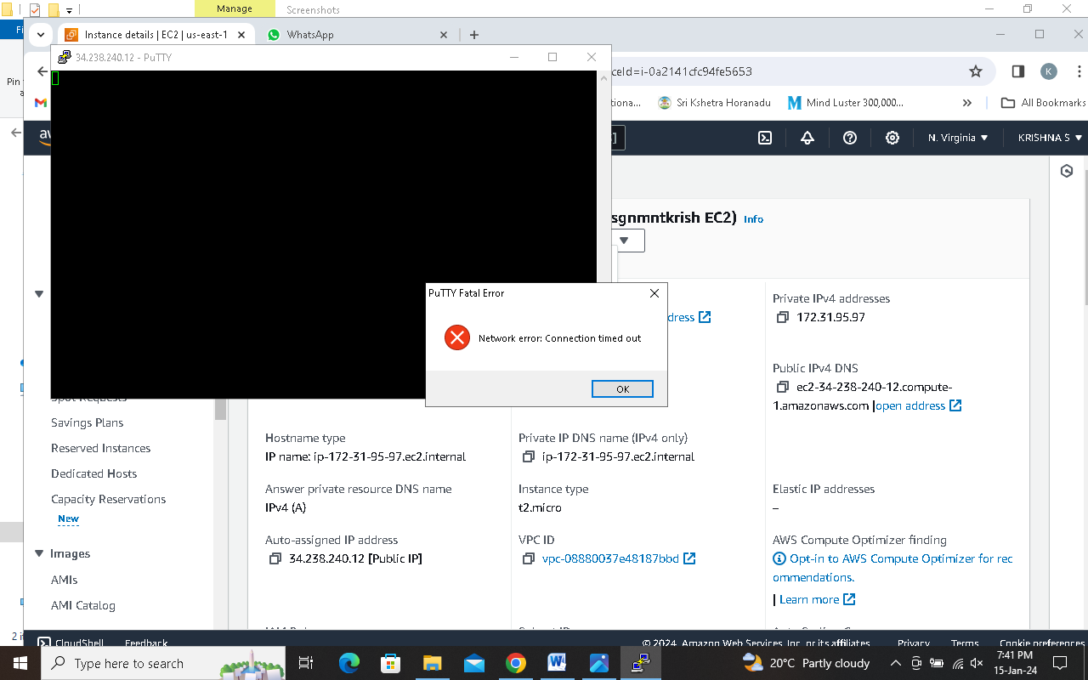

**Assignment Q2: You need to configure an Amazon S3 bucket for a static website. Describe the Steps involved in setting up the bucket, enabling static website hosting, and securing it with appropriate permissions.**

**Step 1 search and select S3 service**

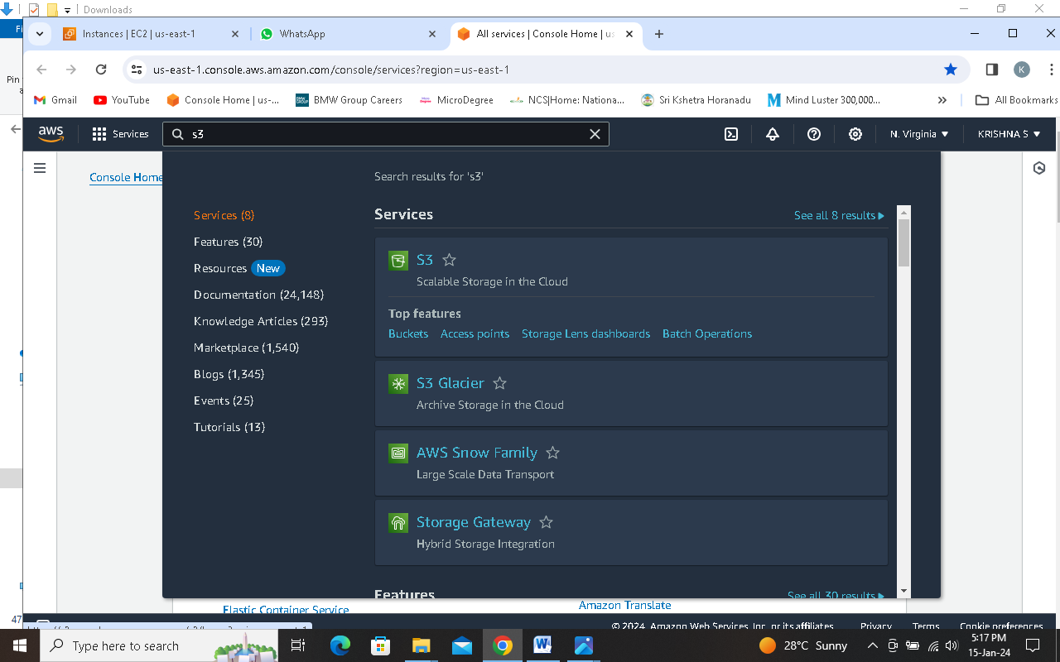

**Step 2 Click on Create Bucket**

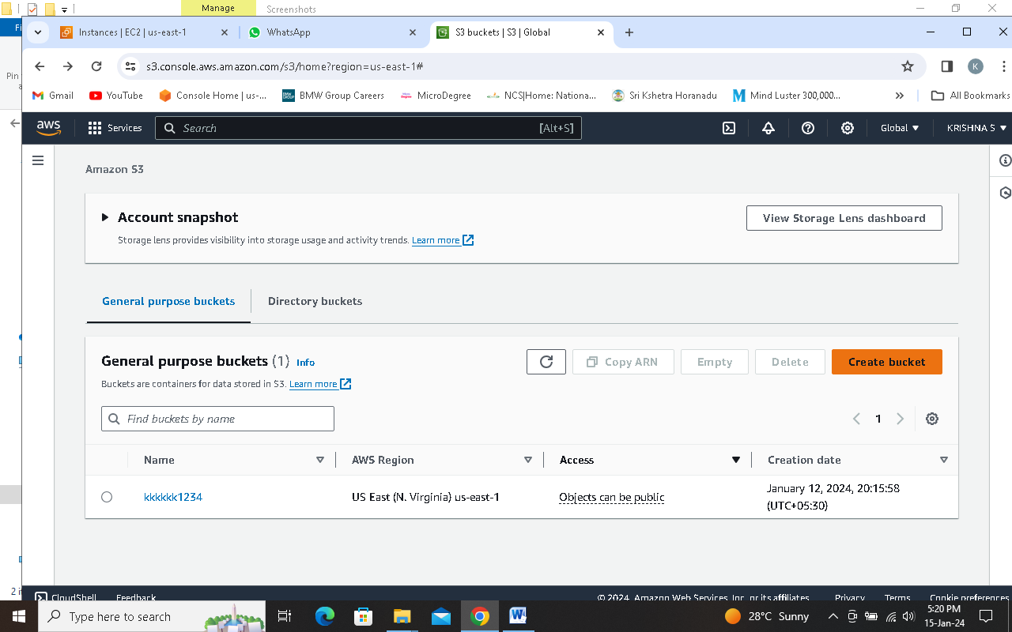

**Step 3 Select the Region which you want or let it be the default (S3 is Region specific service)**

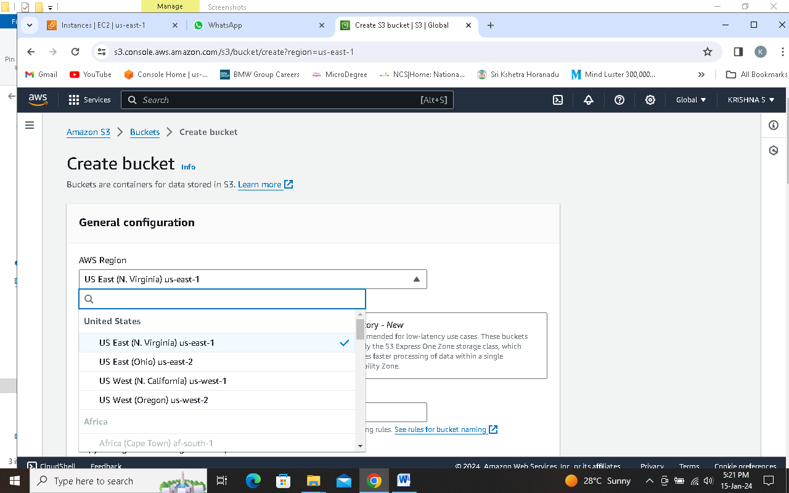

**Step 4 Enter the unique name in Bucket name box**

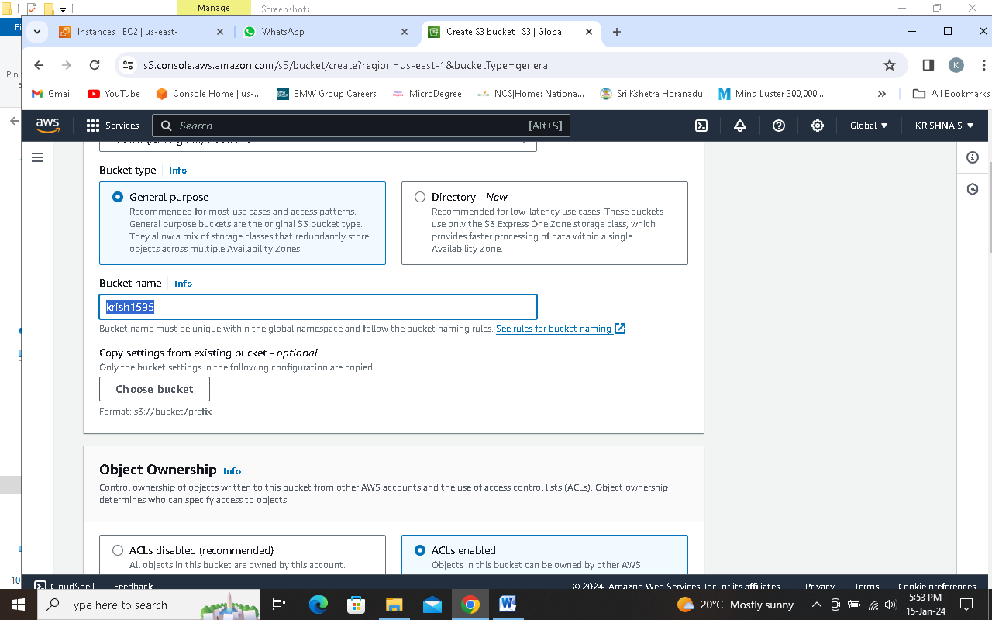

**Step 5 in the Object Ownership select ACLs Enabled**

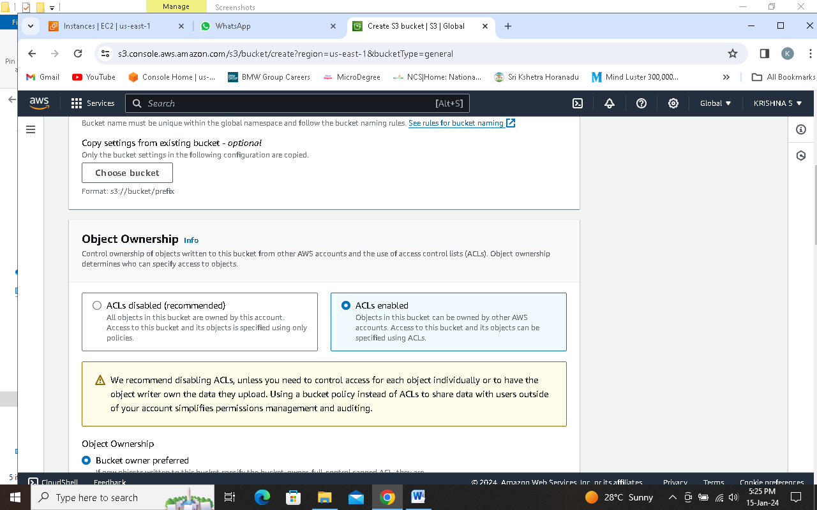

**Step 6 uncheck the Block all public access option in Block Public Access settings for this bucket**

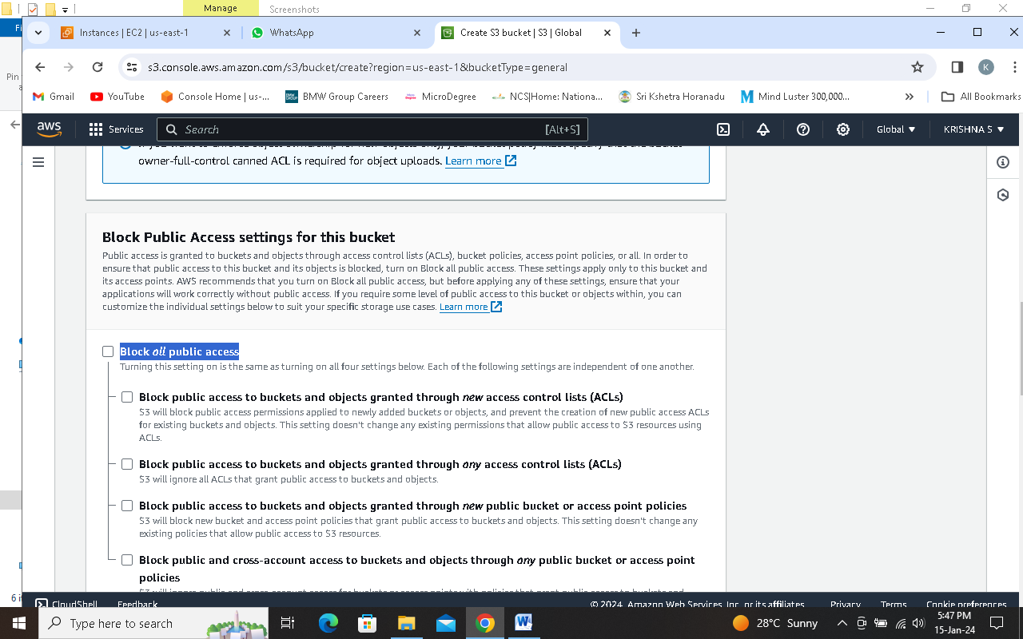

**Step 7 select I acknowledge that the current settings might result in this bucket and the objects within becoming public.**

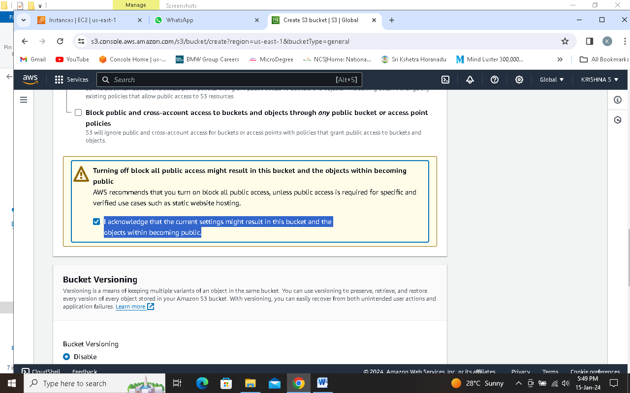

**Step 8 select Enable in the BUcket Versioning**

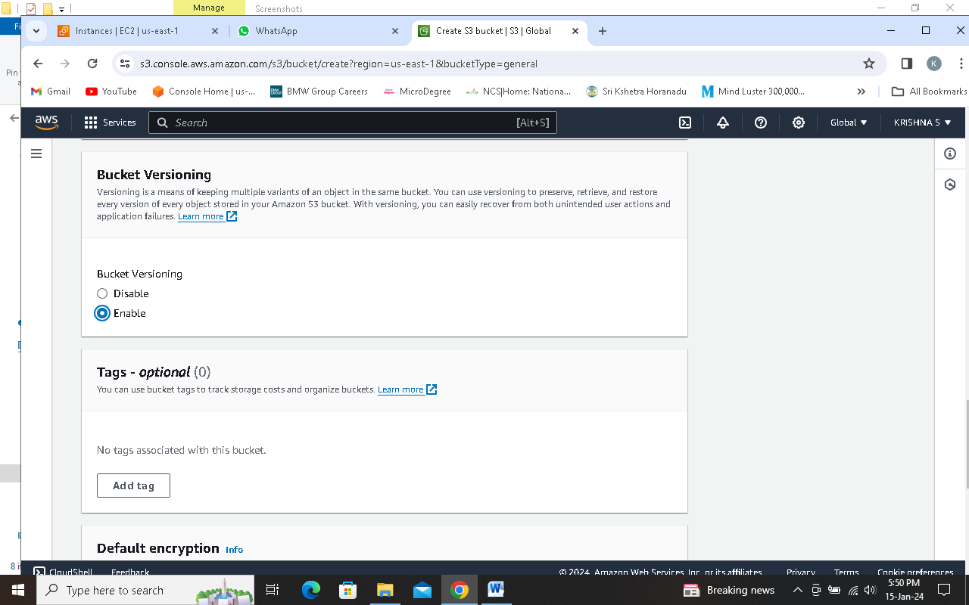

**Step 9 Click on Create Bucket**

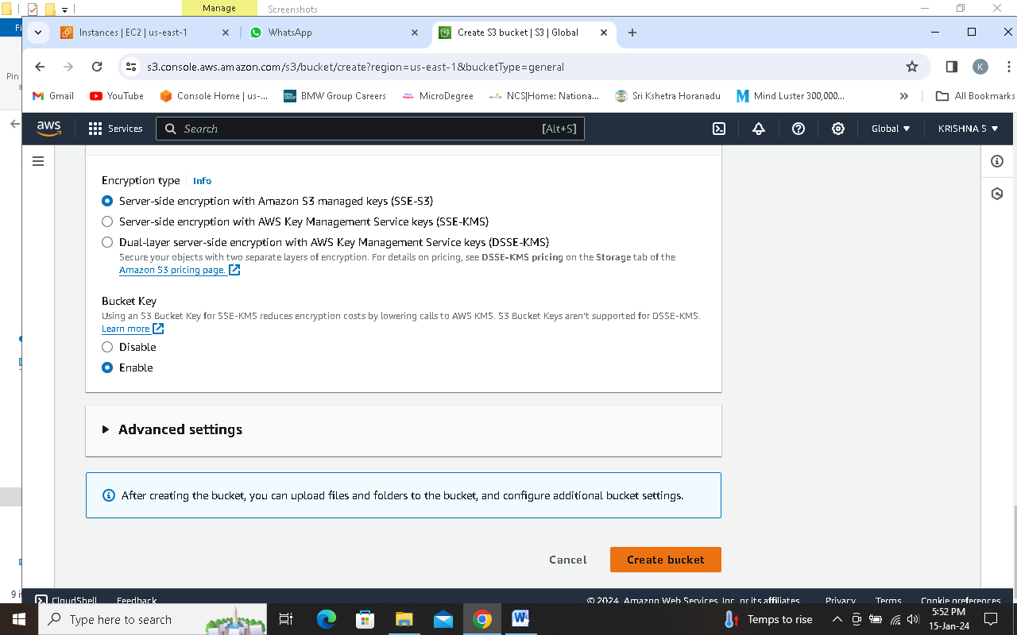

**Step 10 open the created Bucket**

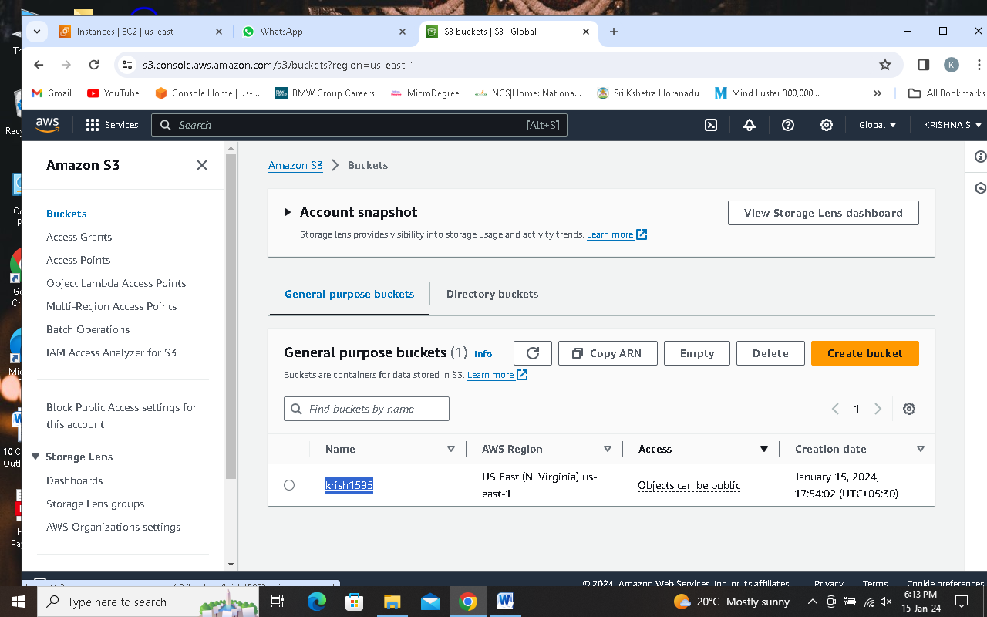

**Step 11 click on upload (or drag and drop)**

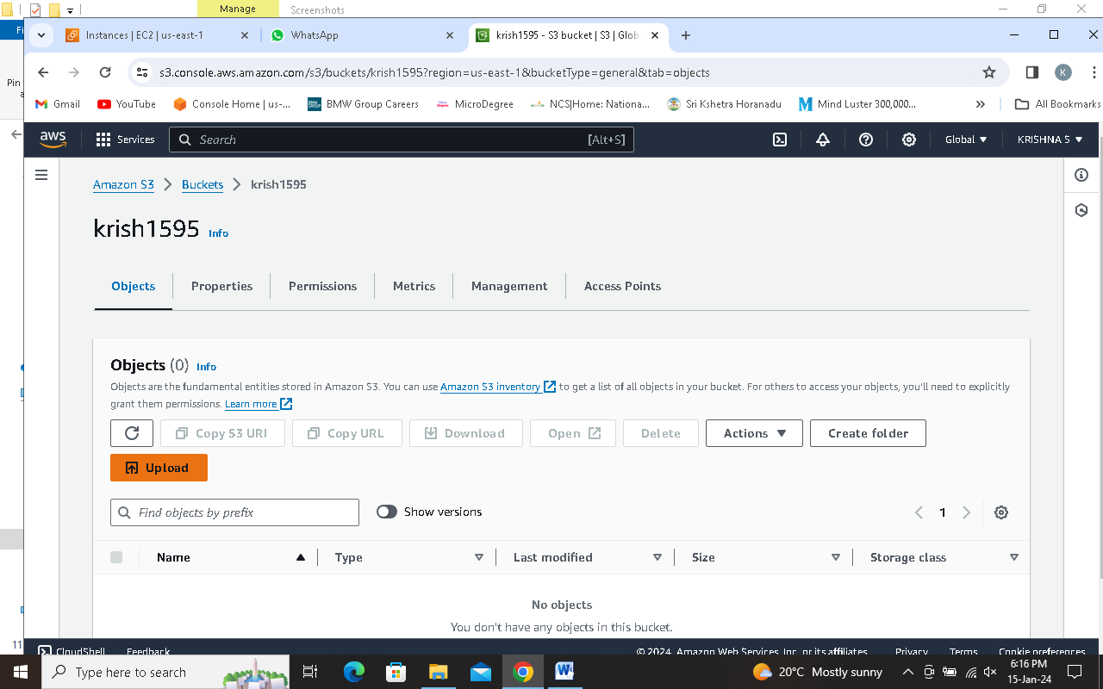

**Step 12 click on Add files**

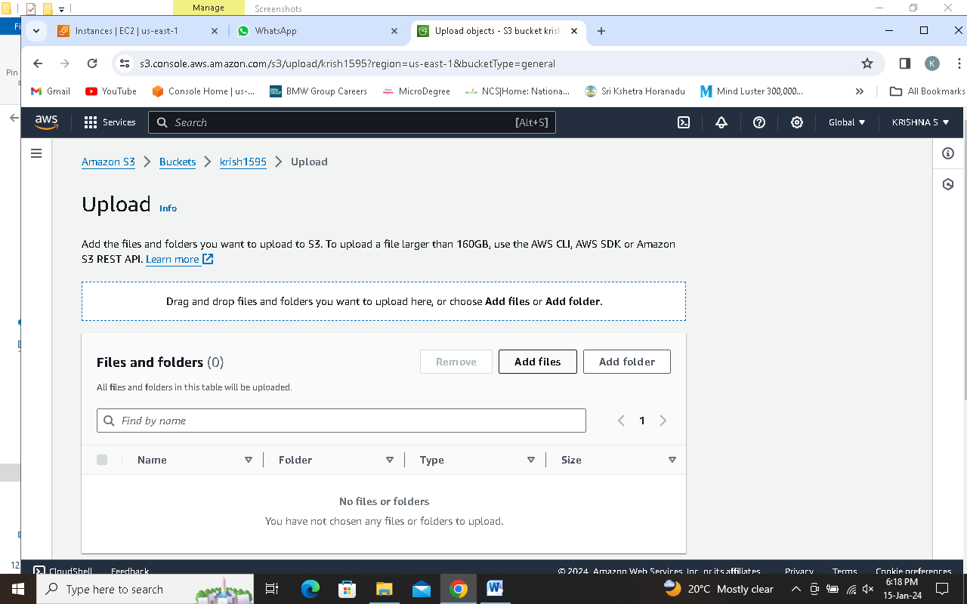

**Step 13 Browse the file**

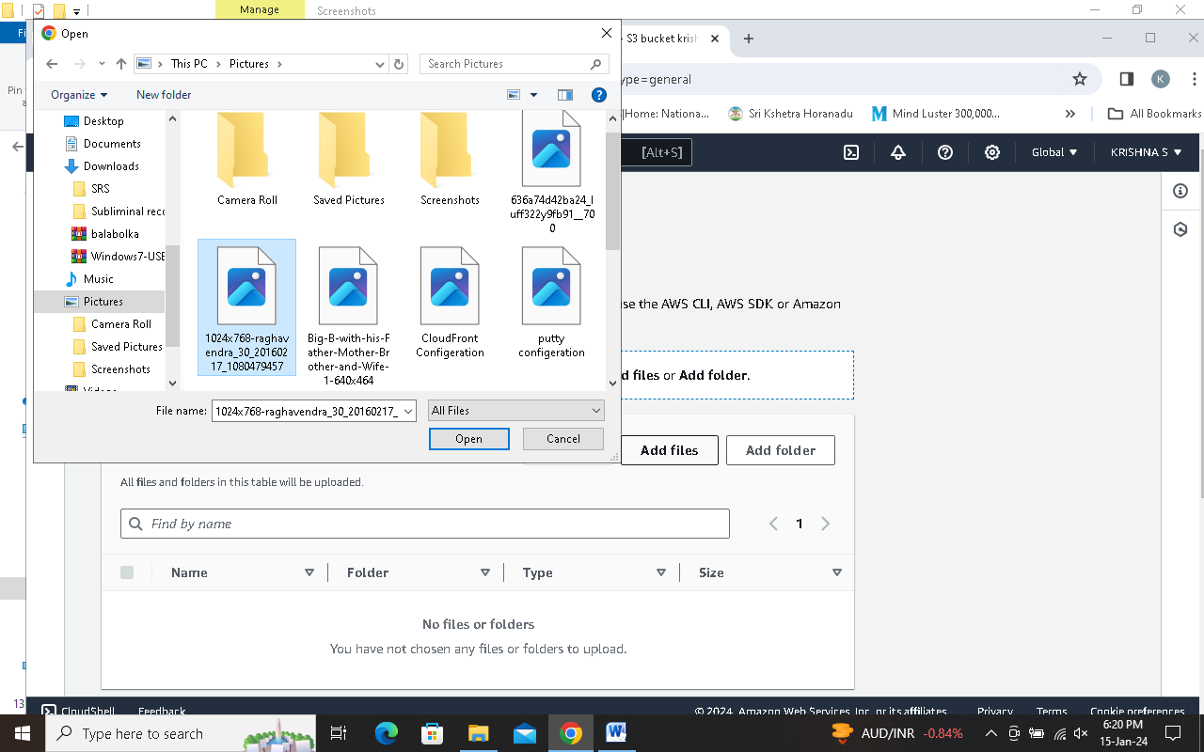

**Step 14 Grant public-read access in Access control list (ACL)**

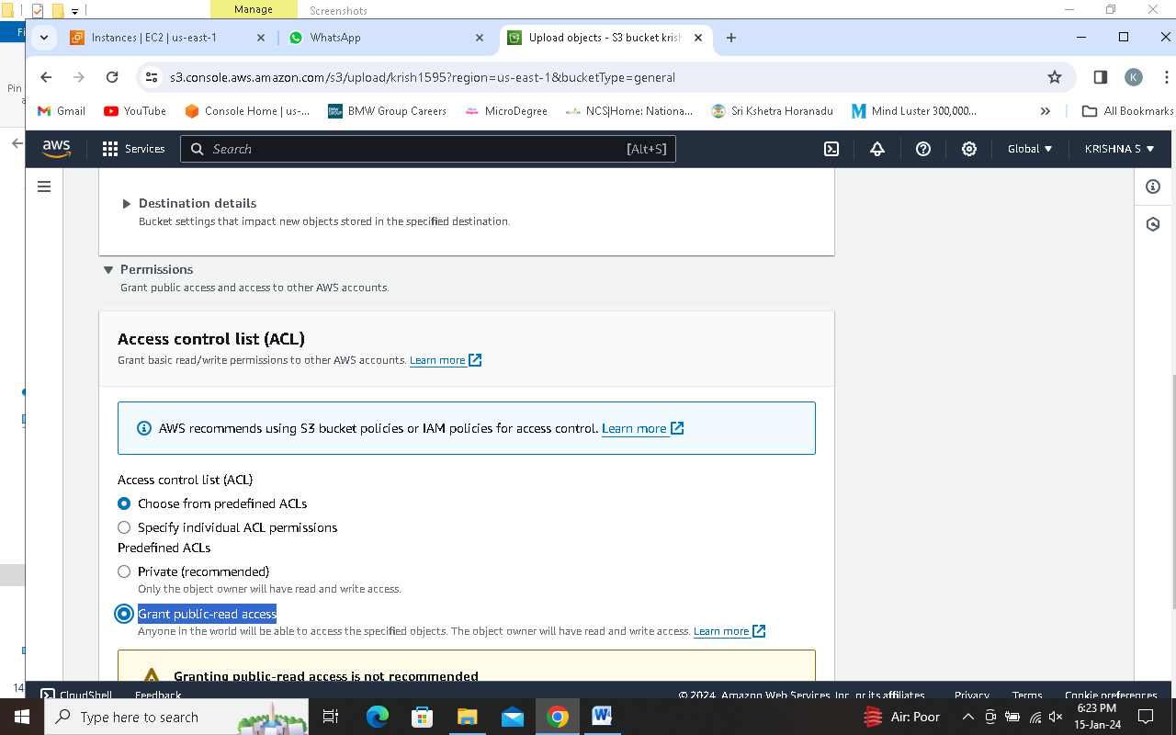

**Step 15 check the I understand the risk of granting public-read access to the specified objects and click Upload.**

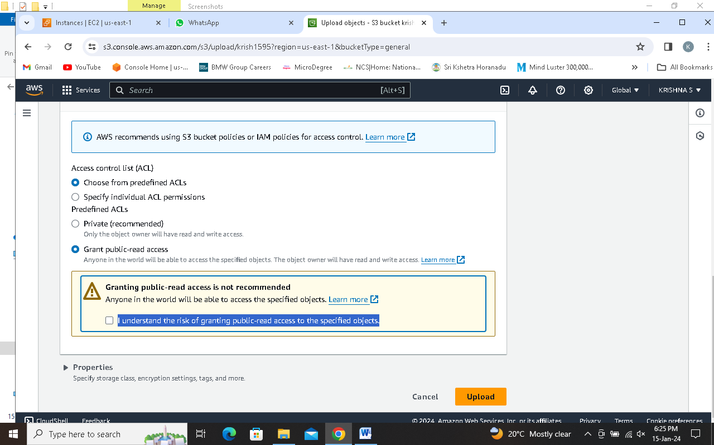

**Step 16 click on Close**

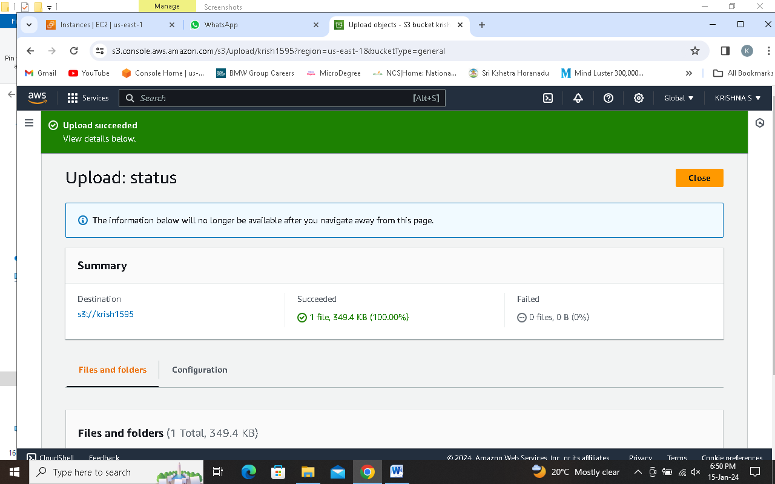

**Step 17 click on Properties and scroll down then select Enable in Edit in the Static website hosting.**

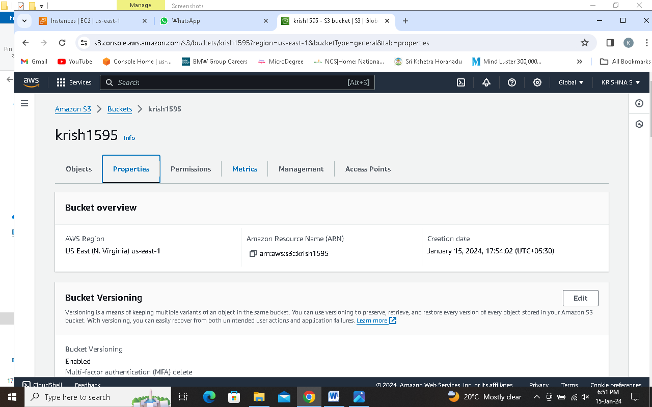

**Step 18 Enter the name of the file which you have uploaded in the Index document.**

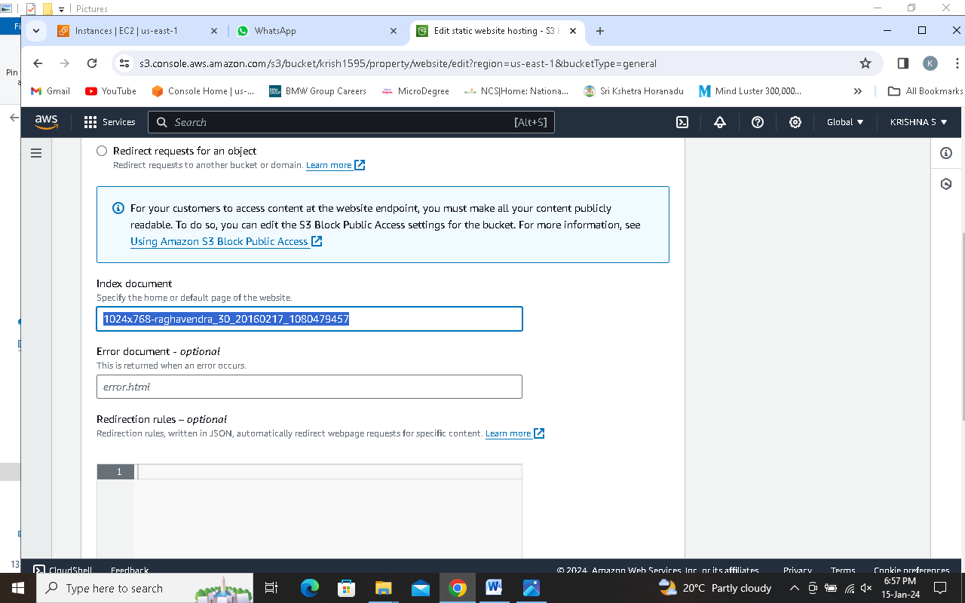

**Step 19 click on save changes.**

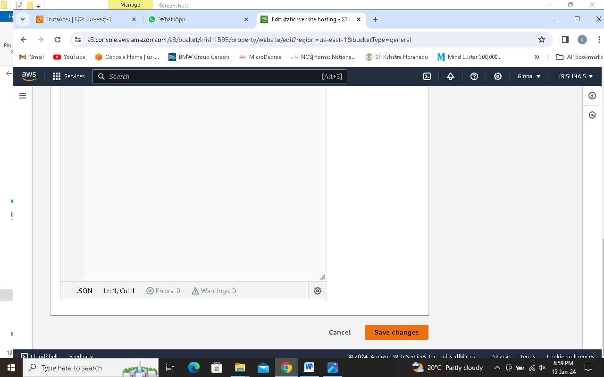

**Step 20 now again click on Buckets**

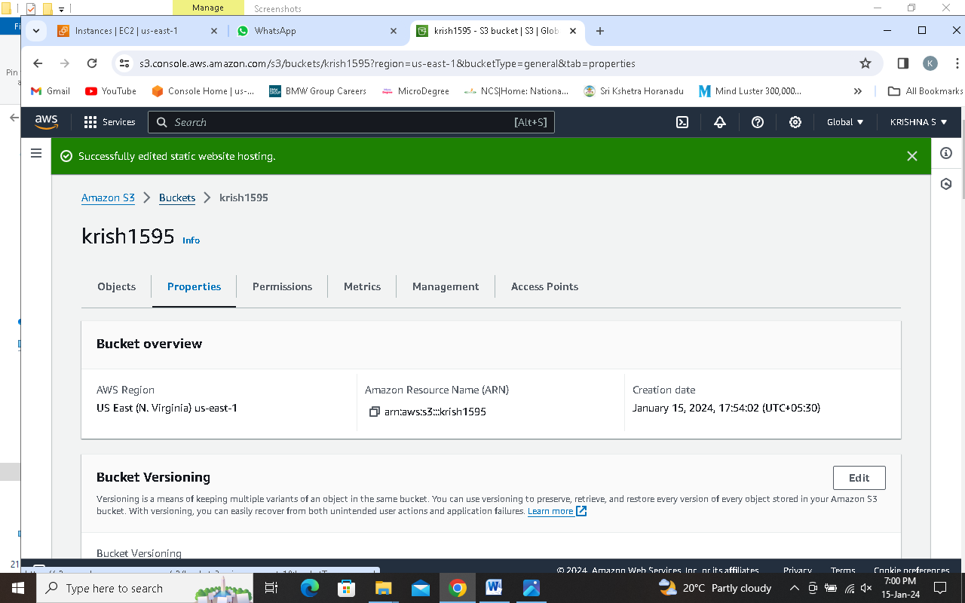

**Step 21 Go to your bucket**

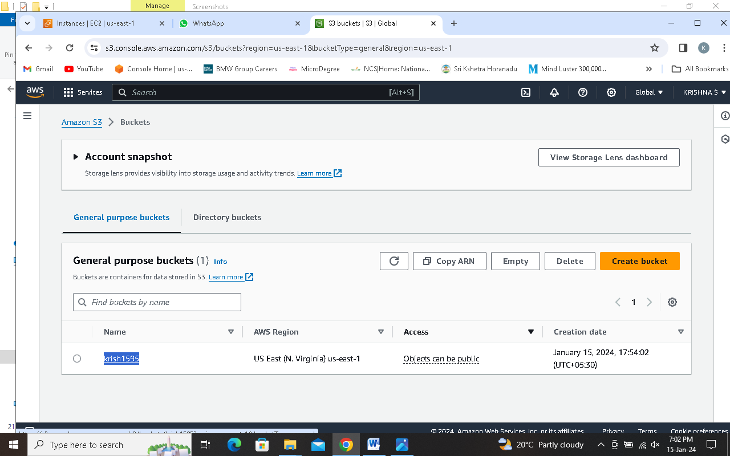

**Step 22 click on the file which you have uploaded**

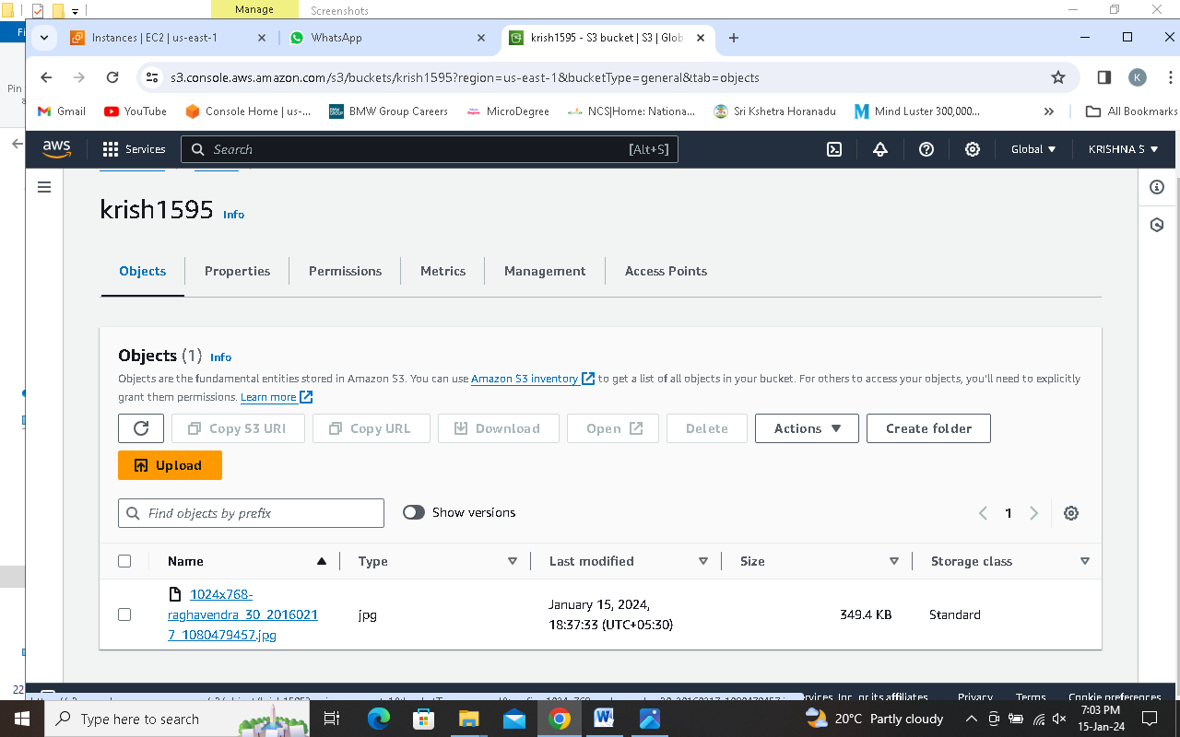

**Step 23 click on object URL**

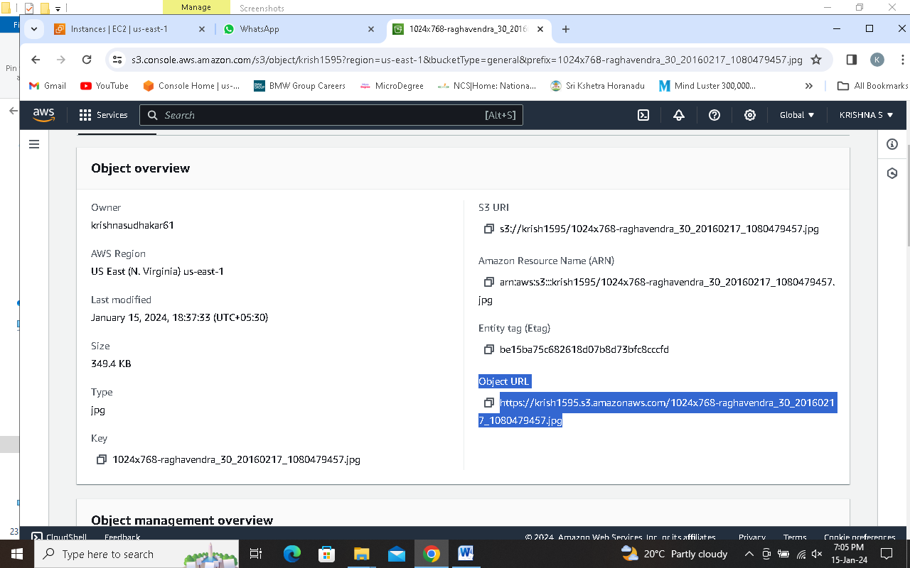

**Step 24 Its done**

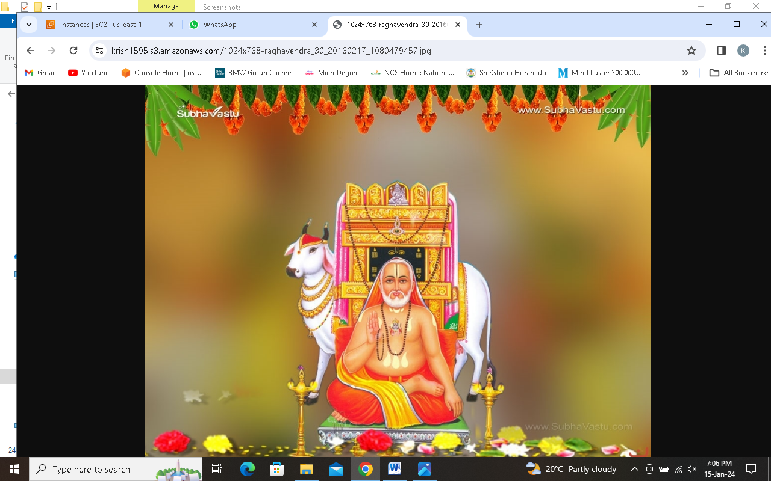

**Assignment Q3: Establish VPC peering between two separate VPCs. Define the necessary routing configurations, security group rules, and considerations for communication between resources in each VPC.**

**Step 1 search VPC and click on that**

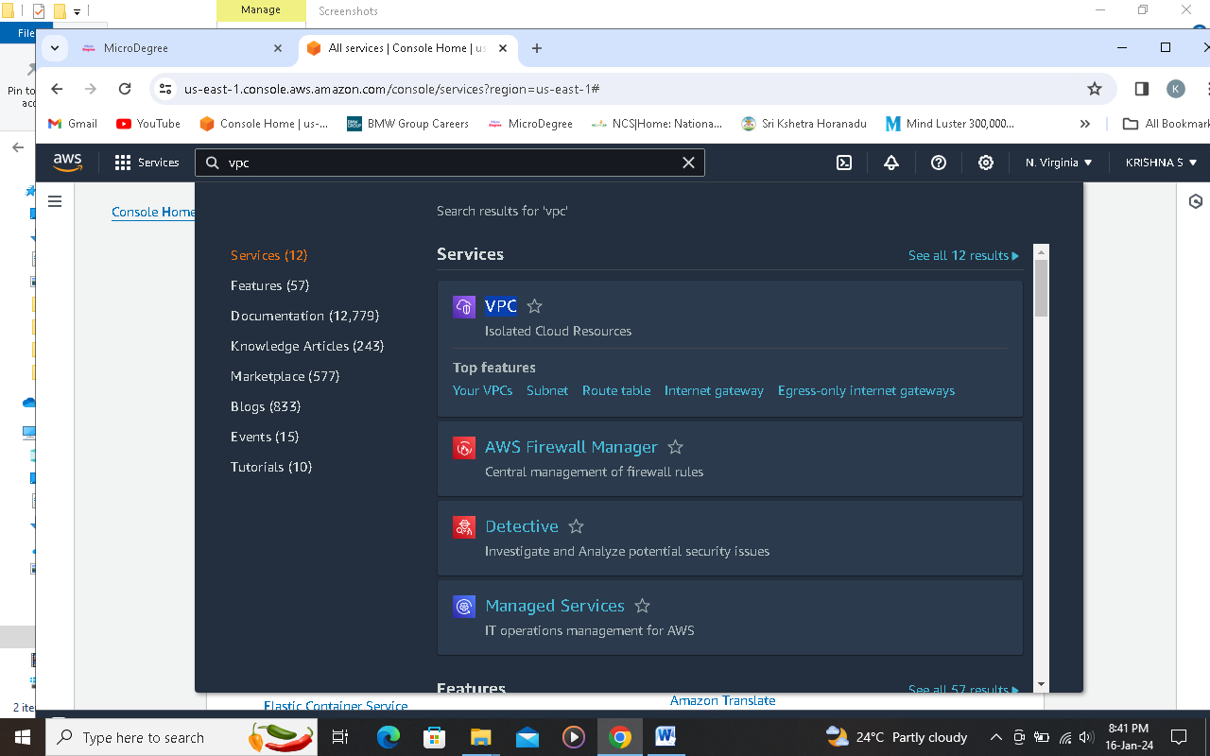

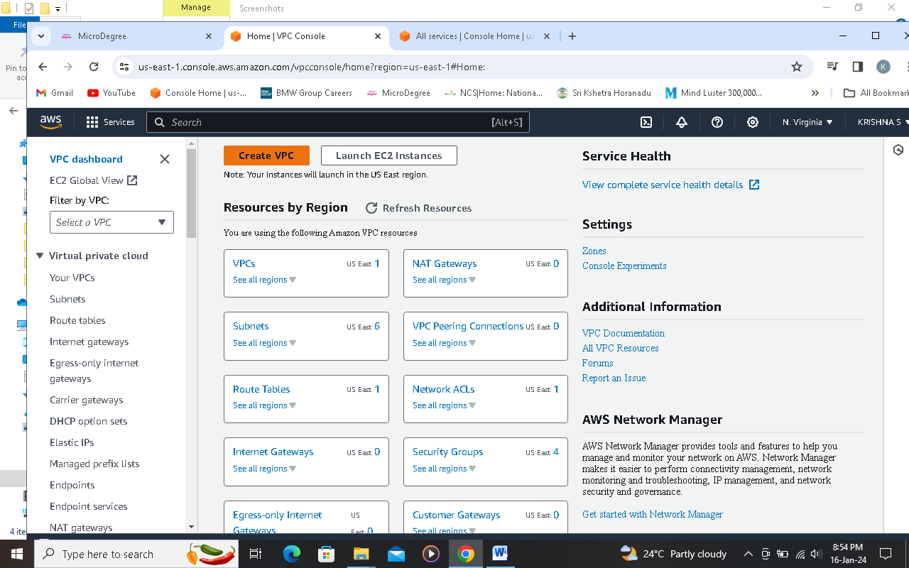

**Step 2 click on create VPC**



**Step 3 Select VPC only (for Indivisual Steps)**

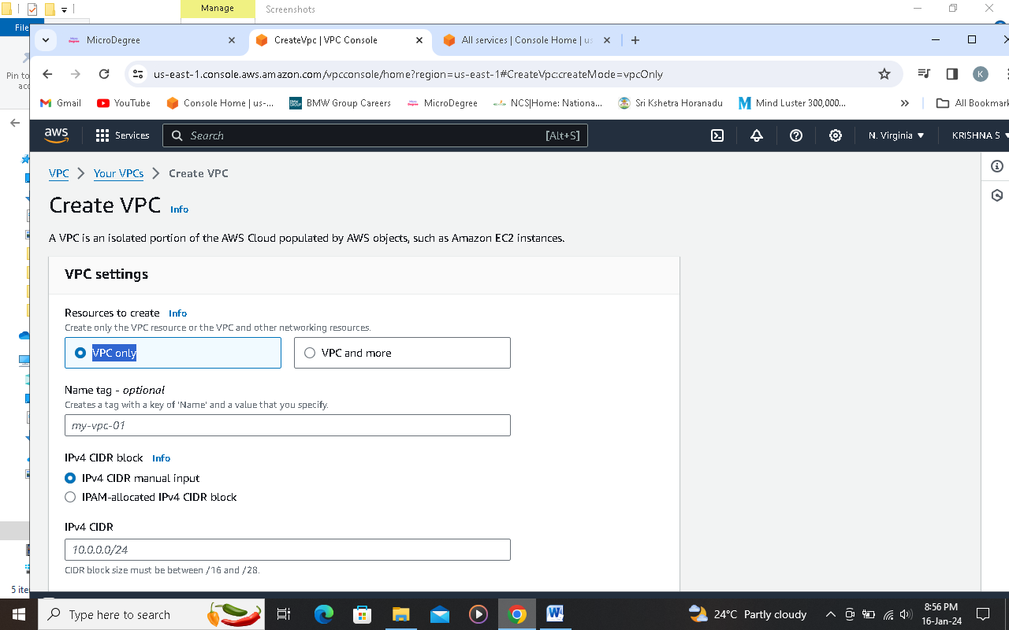

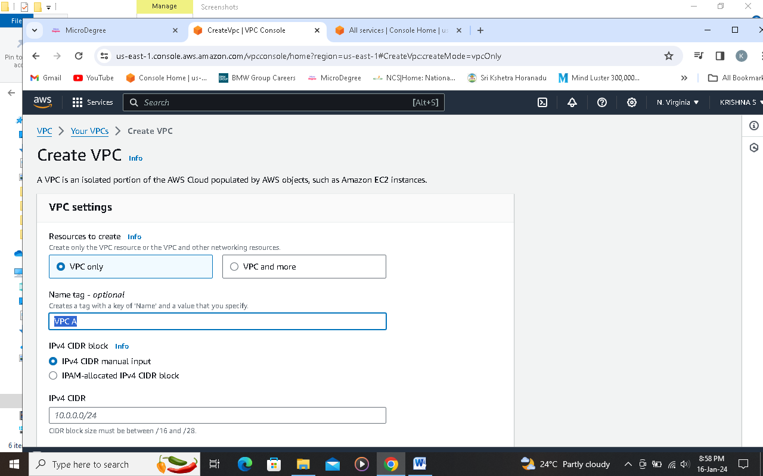

**Step 4 mention any name in name tag**



**Step 5 enter CIDR range**

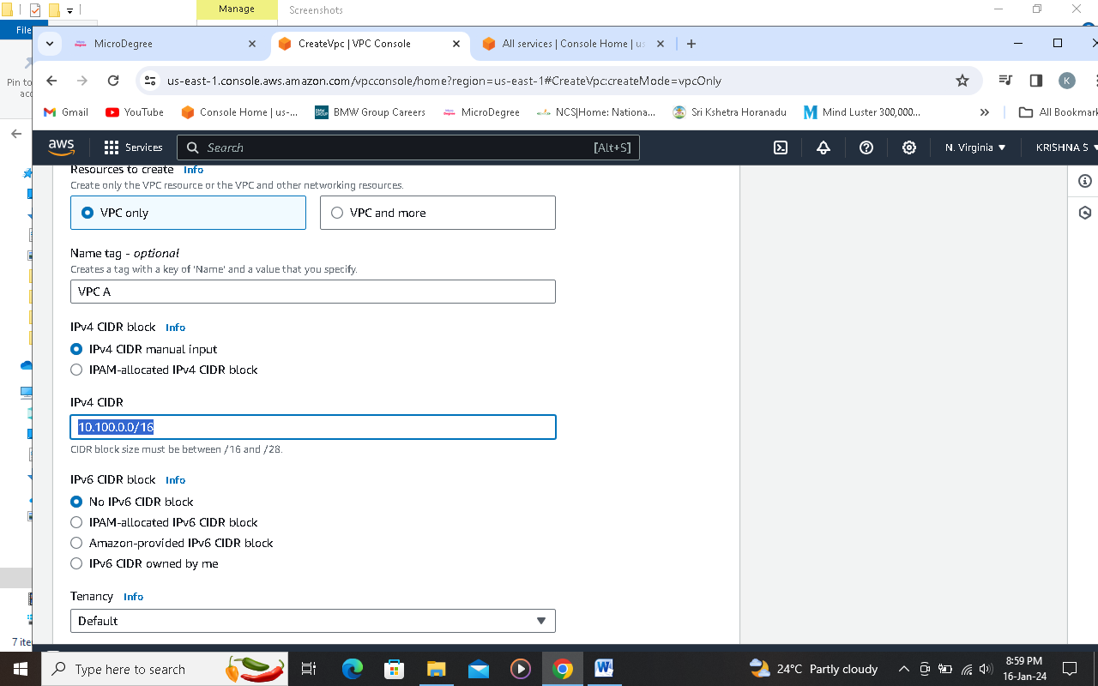

**Step 6 click on create VPC**

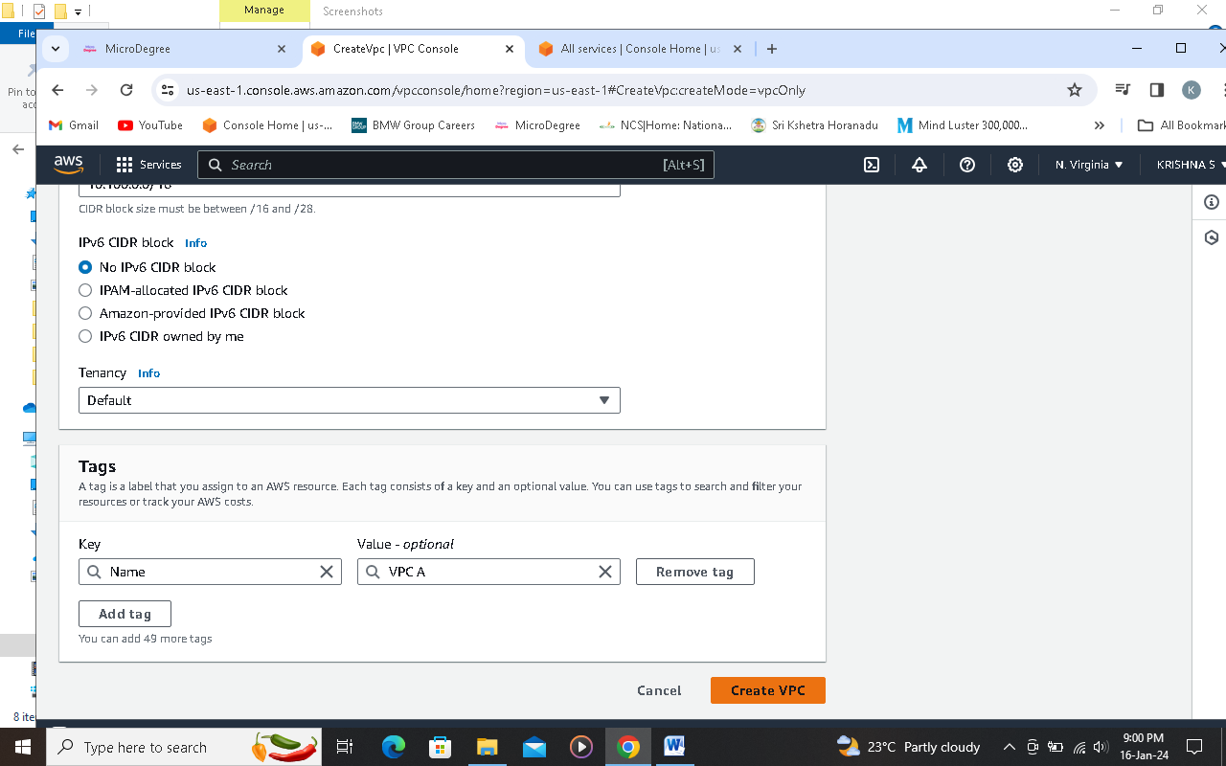

**Step 7 click on your VPCs**

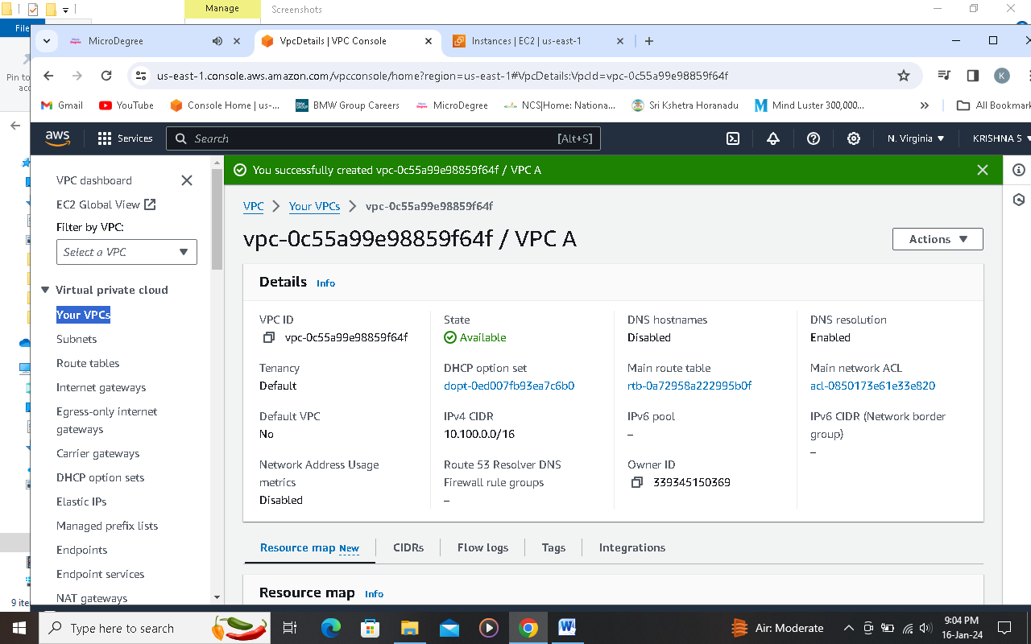

**Step 8 click on Subnet and then click create subnet**

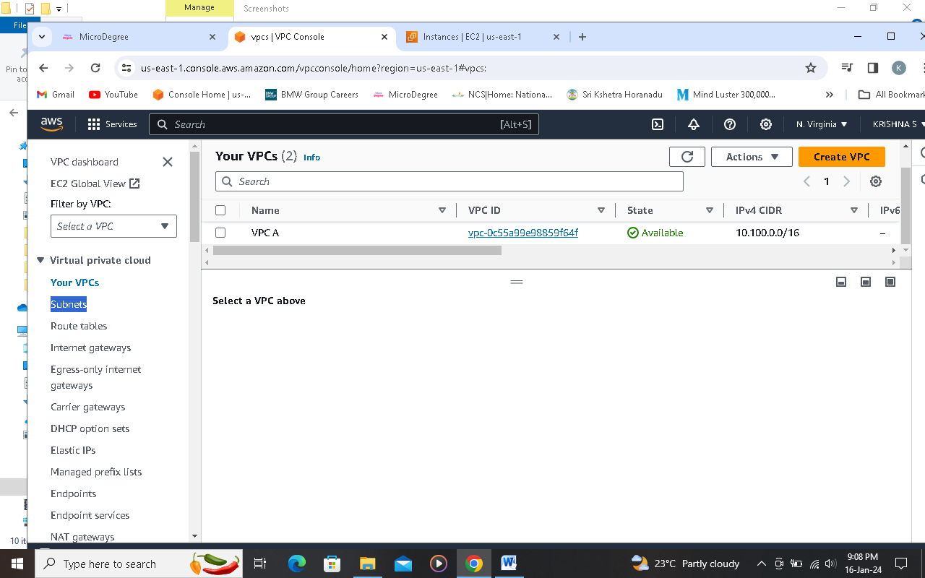

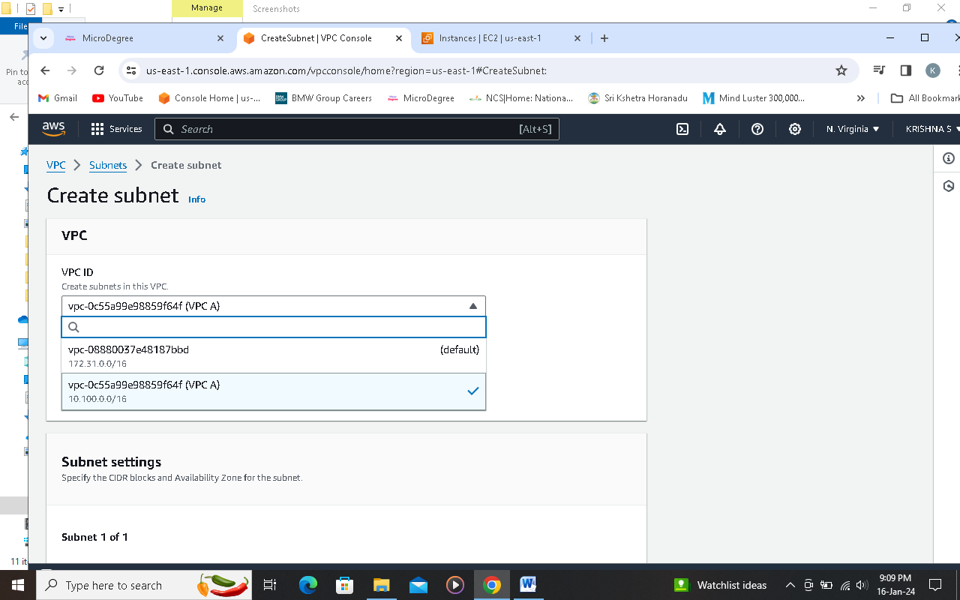

**Step 9 select the VPC which ypou have already created from the VPC ID dropdown list**



**Step 10 mention a name in subnet name box**

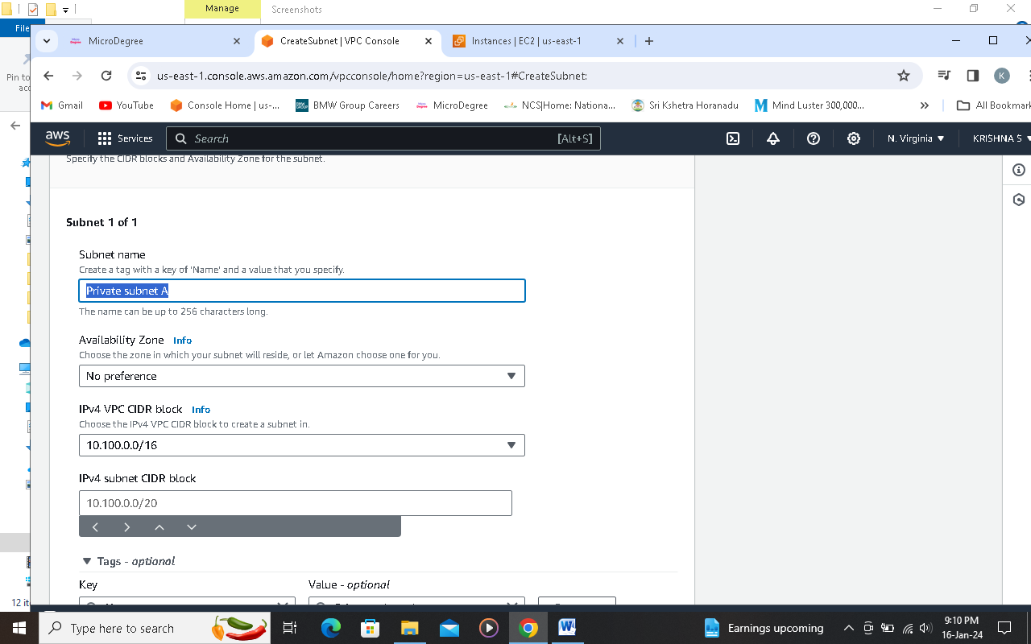

**Step 11 mention CIDR range in IPv4 subnet CIDR block.png**

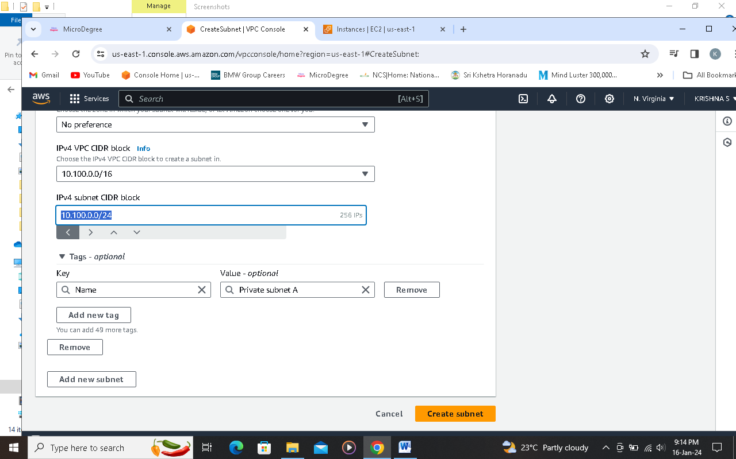

**Step 12 click on add new subnet.png**

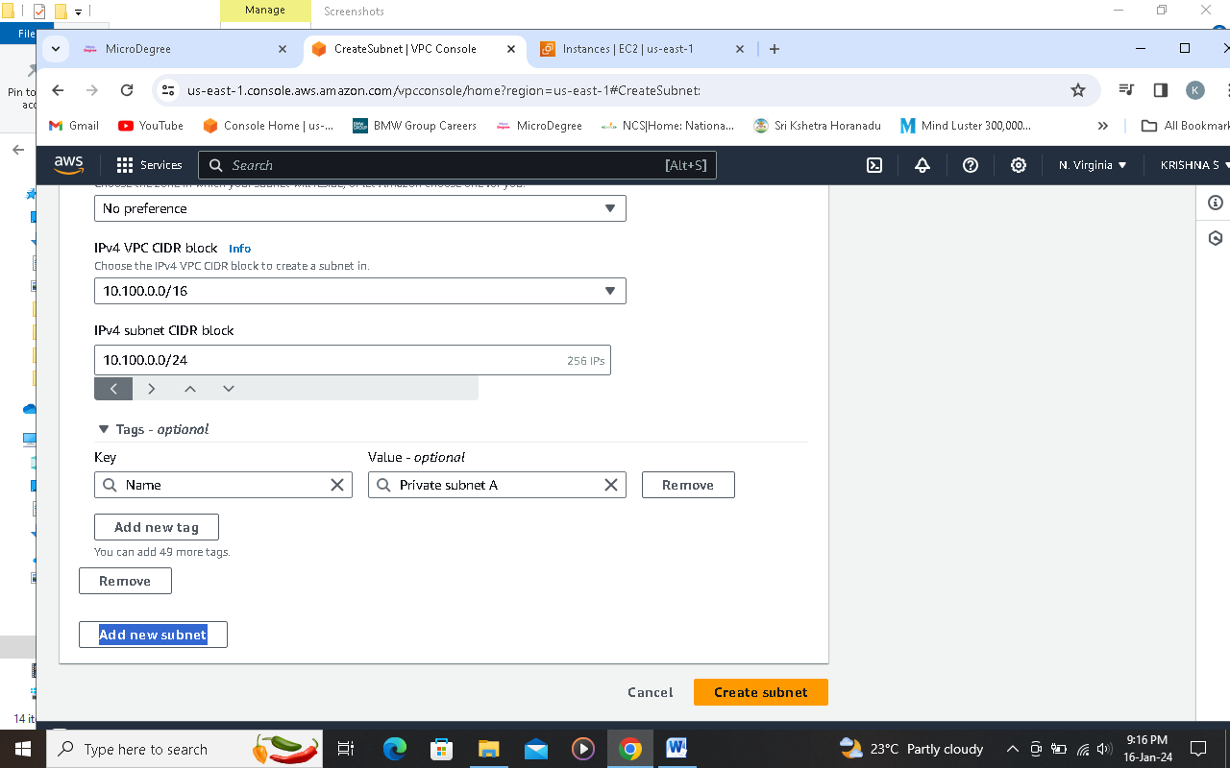

**Step 13 create second Subnet.png**

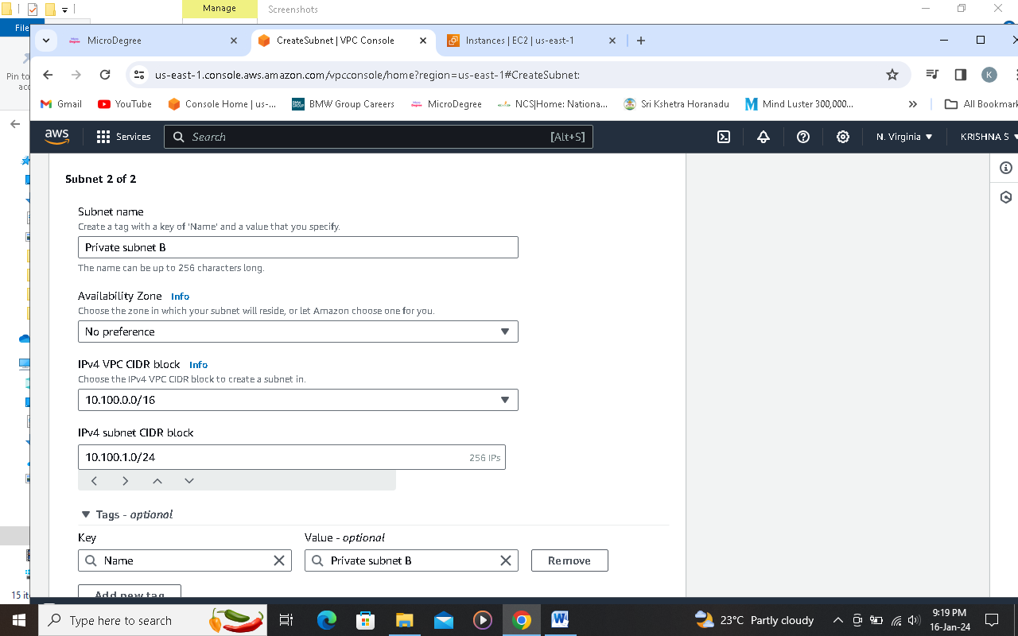

**Step 14 subnets created.png**

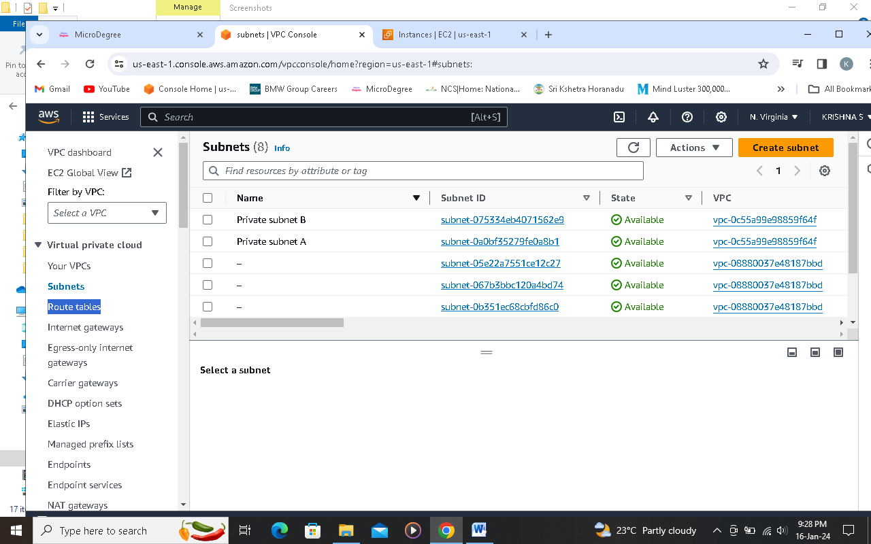

**Step 15 click on route table and create route table**

**Step 17 click create Route table**

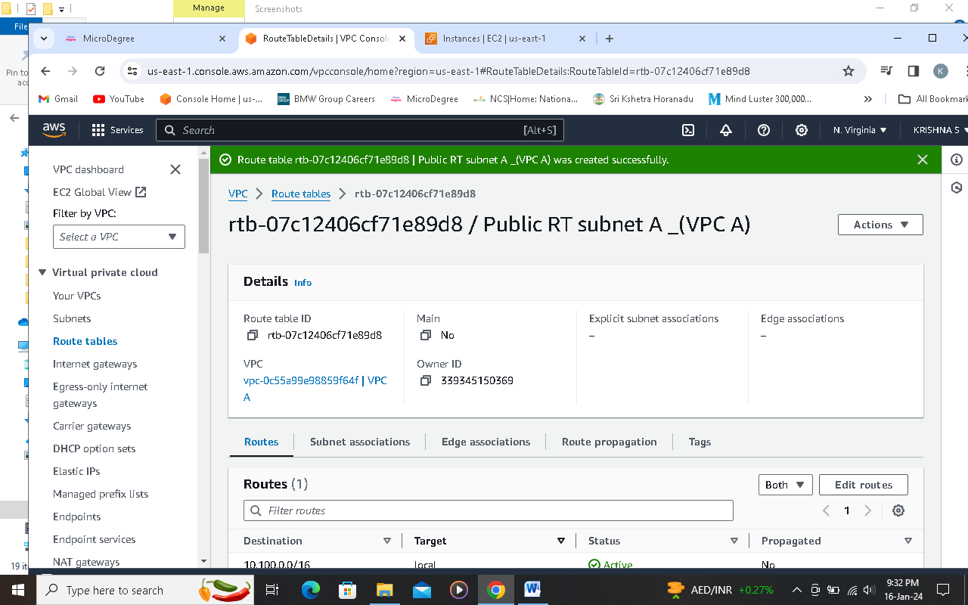

**Step 18 click on subnet associations and edit subnet associations to associate any subnet with route table**

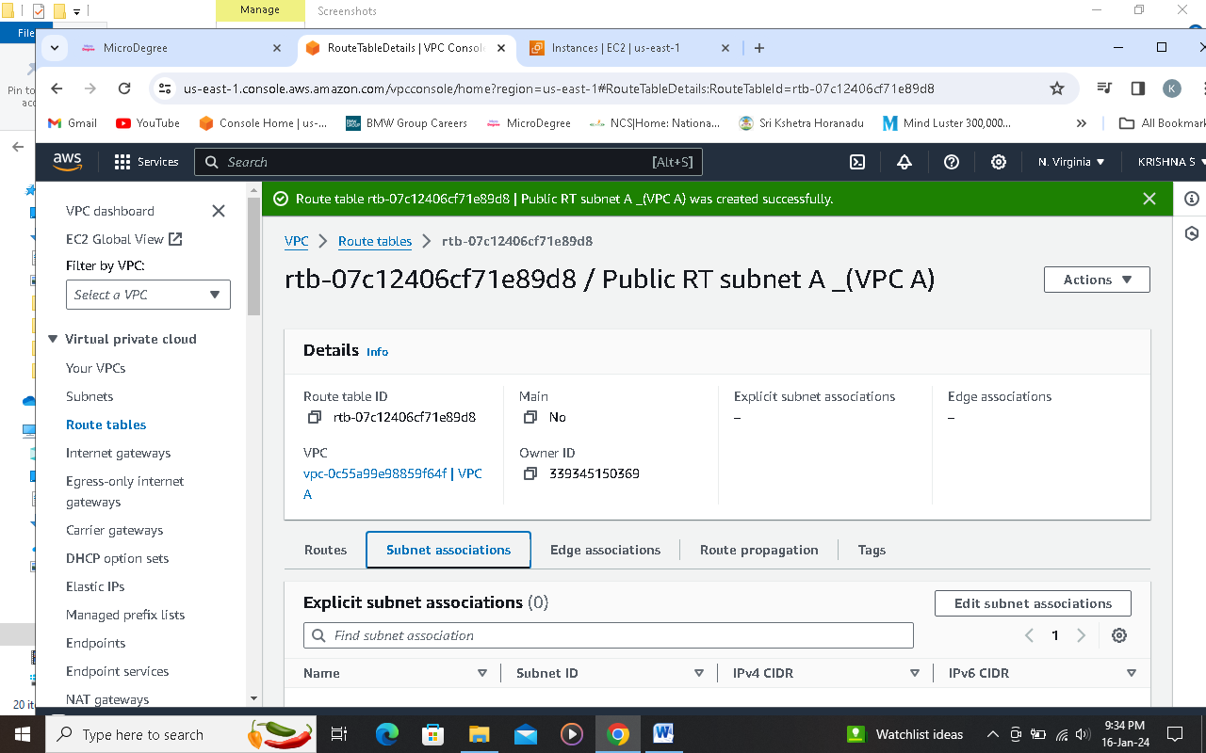

**Step 19 select a subnet click on save changes**

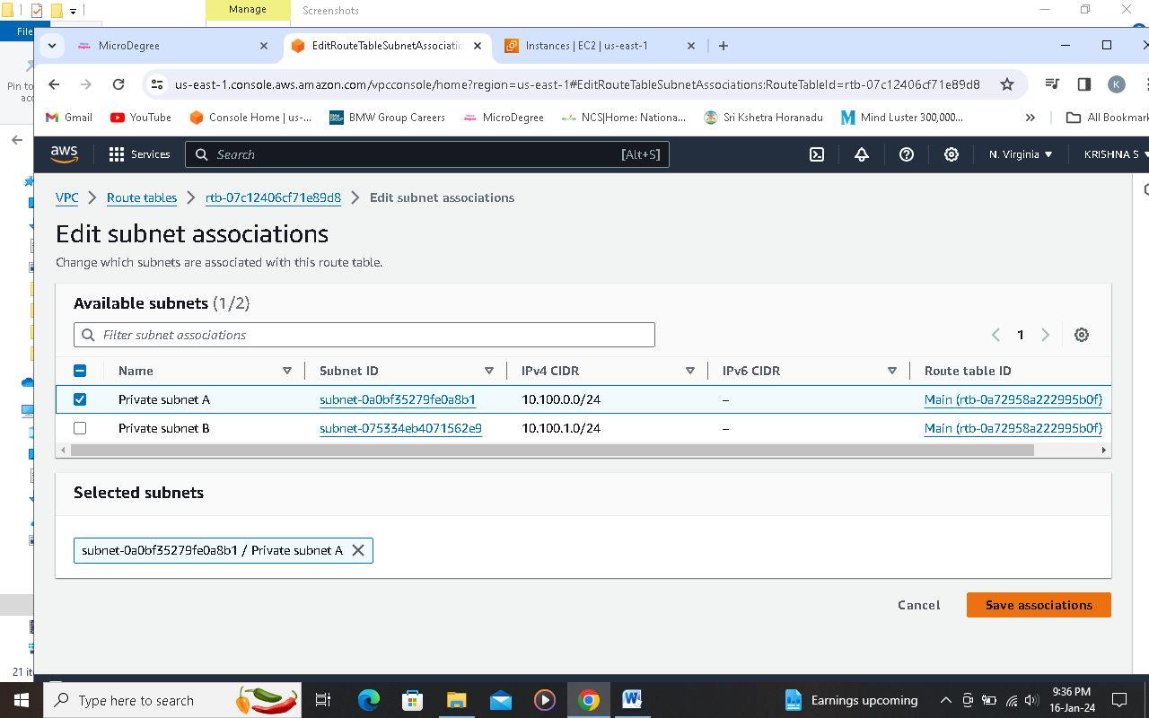

**Step 20 using same Steps createed one more route table**

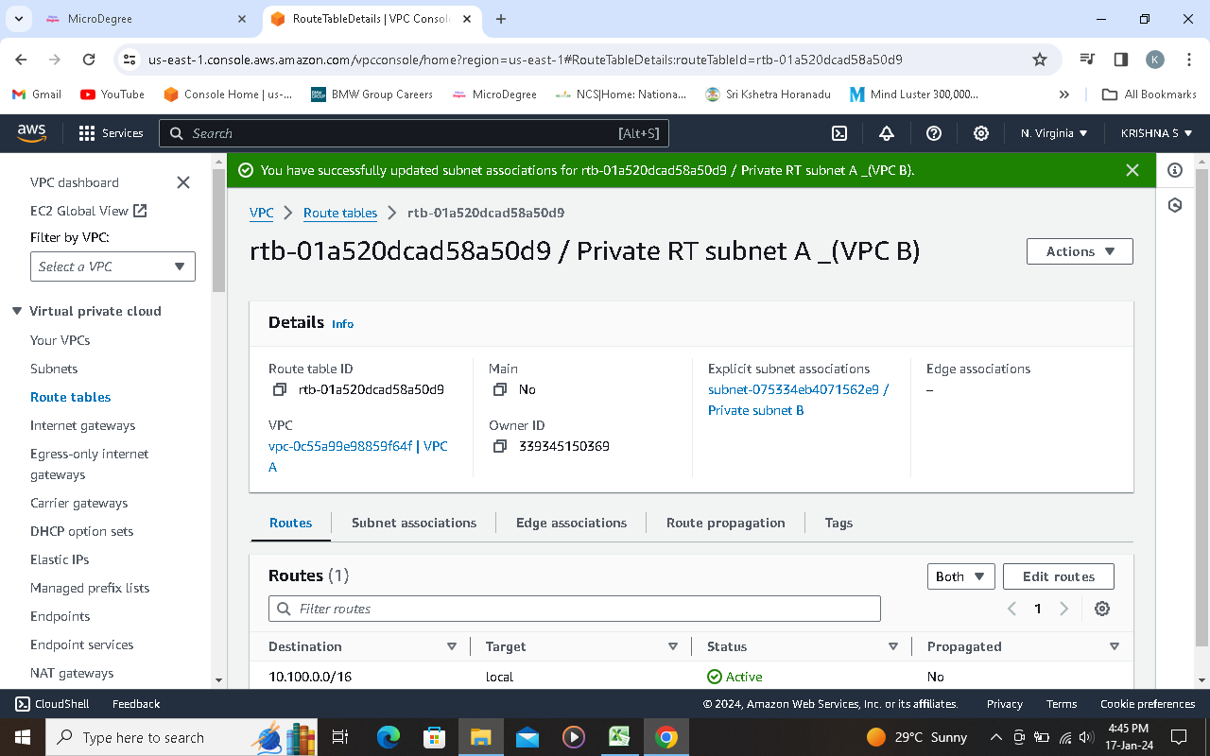

**Step 21 click on Internet gateways**

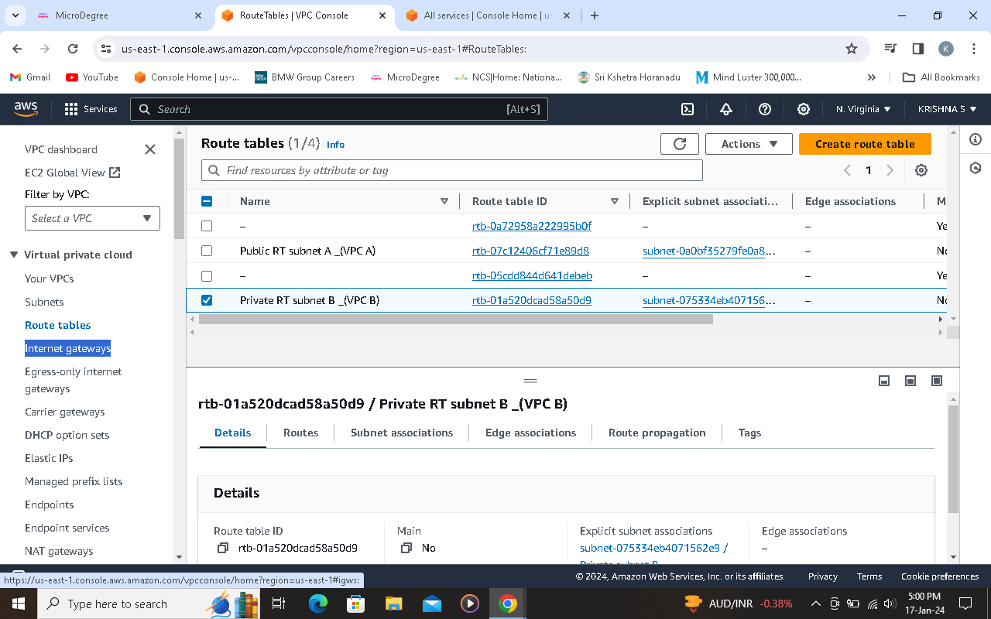

**Step 22 click on Internet gateways and create internet gateways**

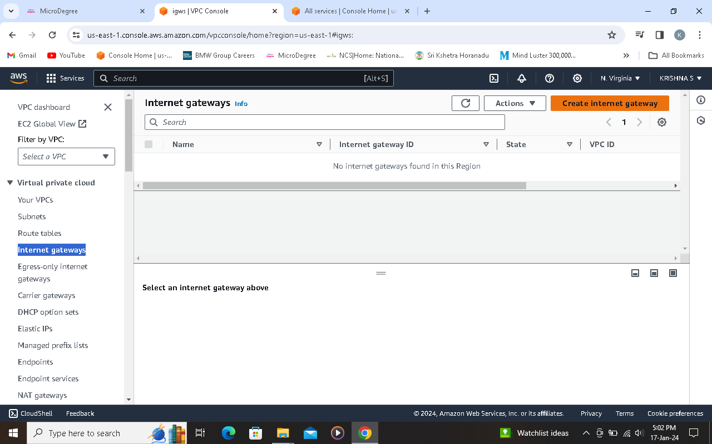

**Step 23 give a name and create IGW**

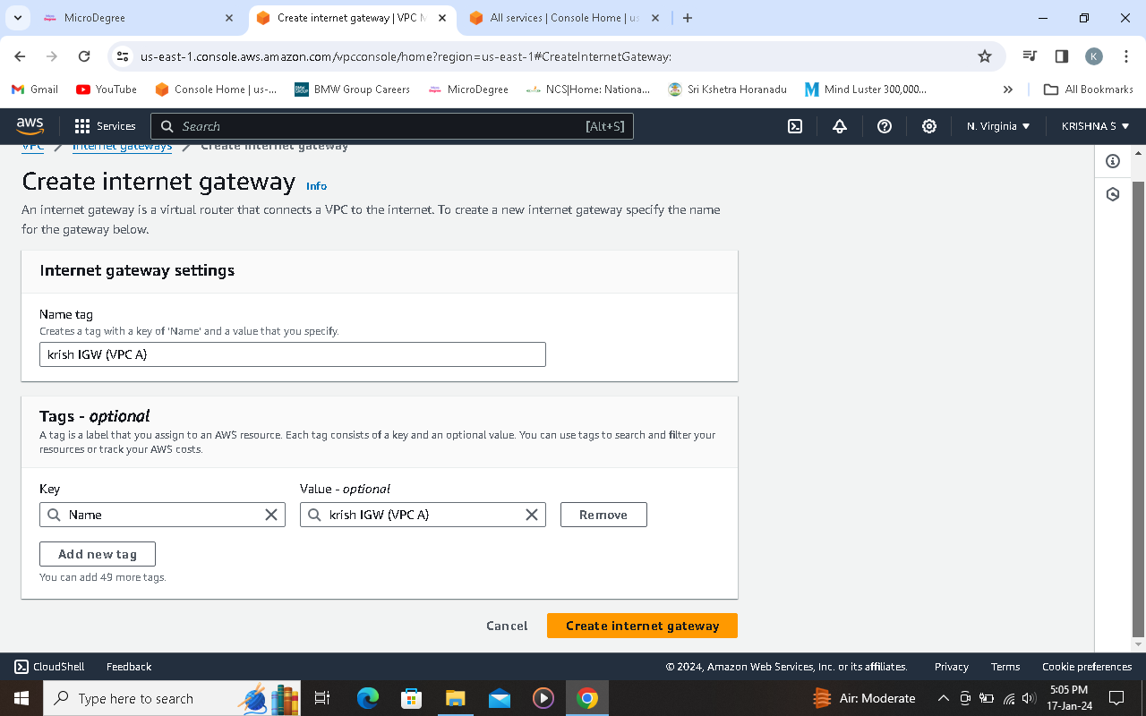

**Step 24 click on attach to VPC , select a VPC from the list and click on attach internet gateway**

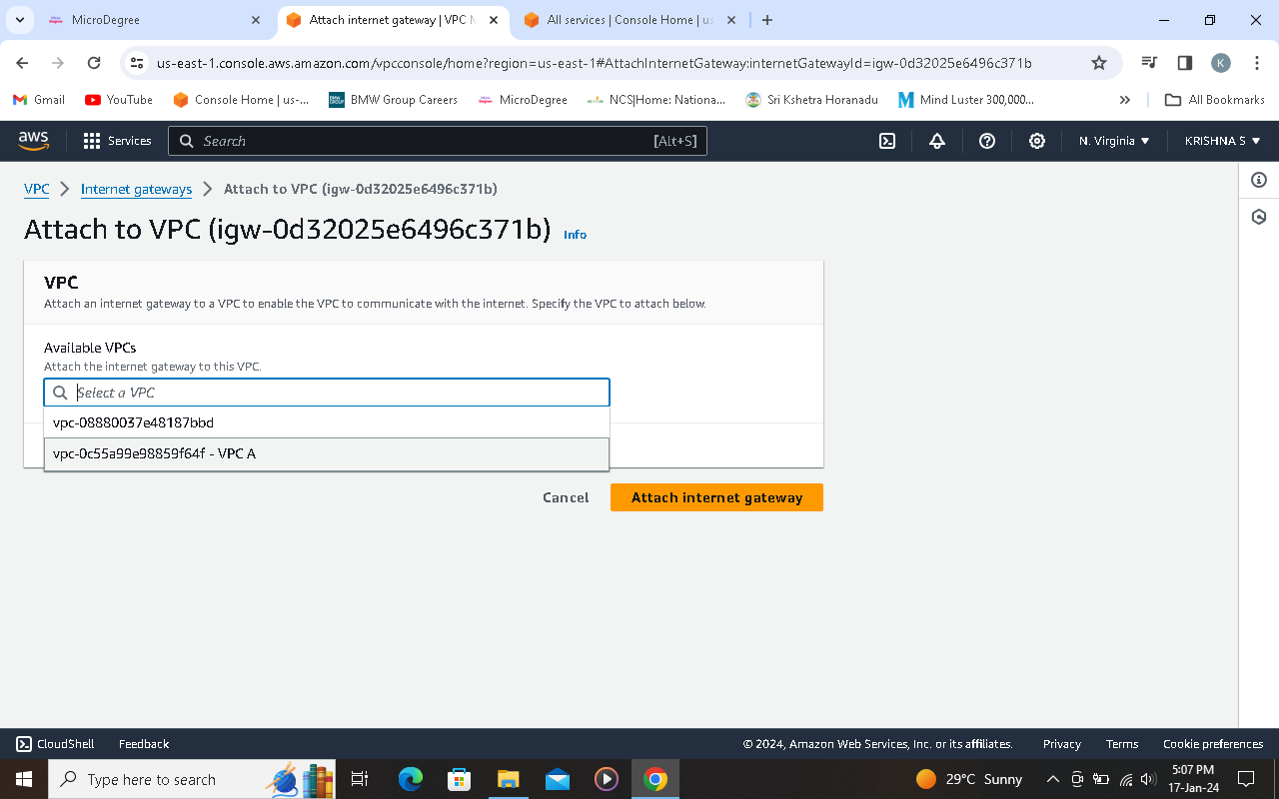

**Step 25 go to route table and pick a route table to make associate**

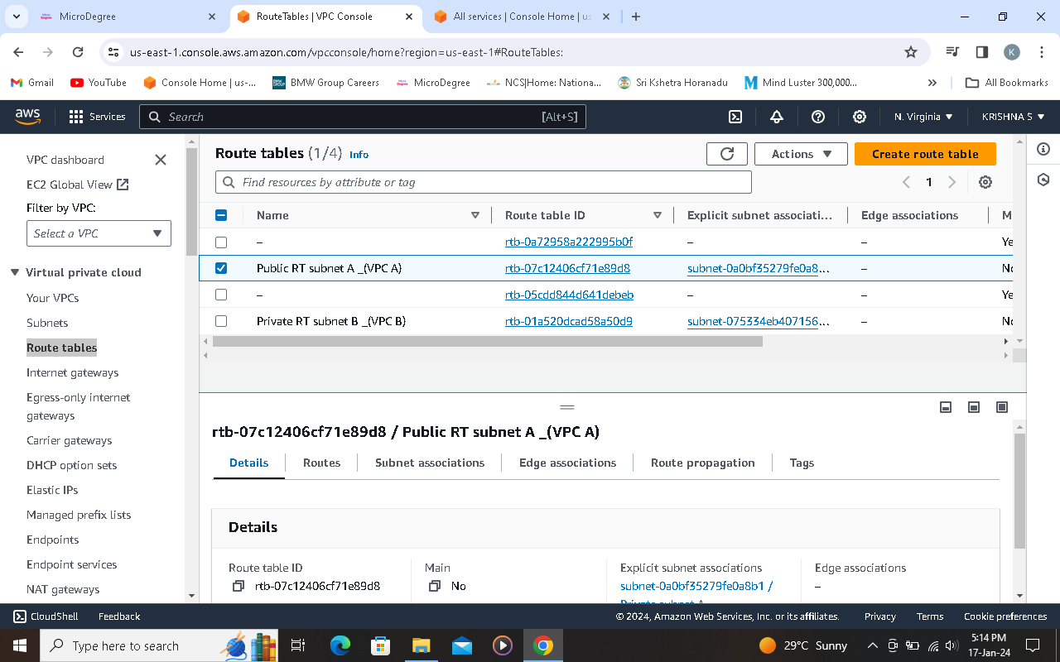

**Step 26 click on edit route**

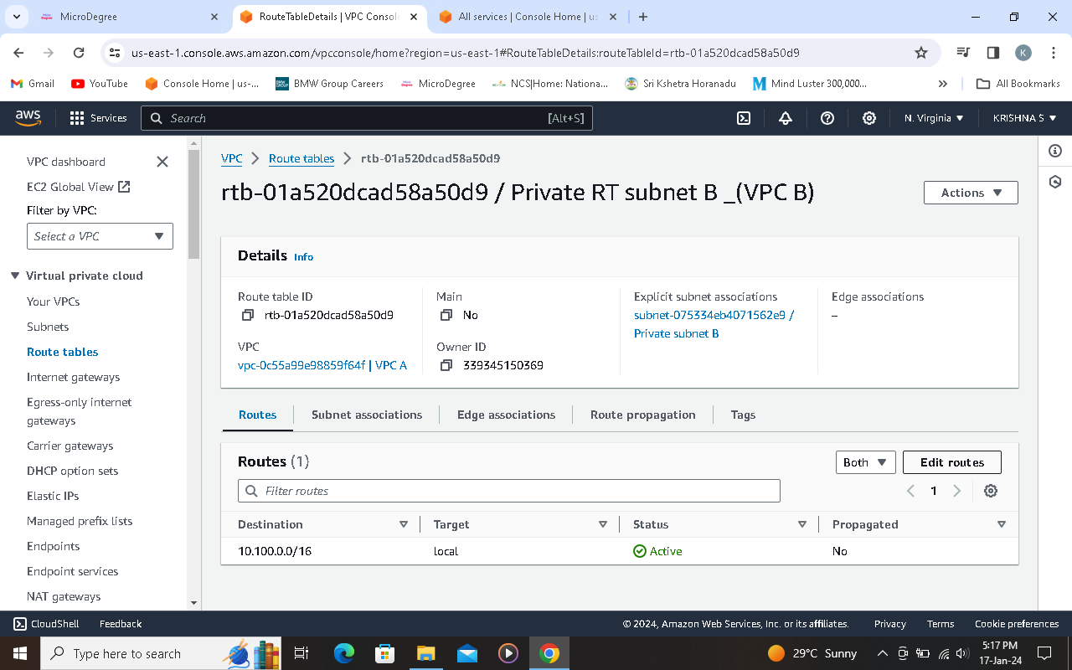

**Step 27 click on add route**

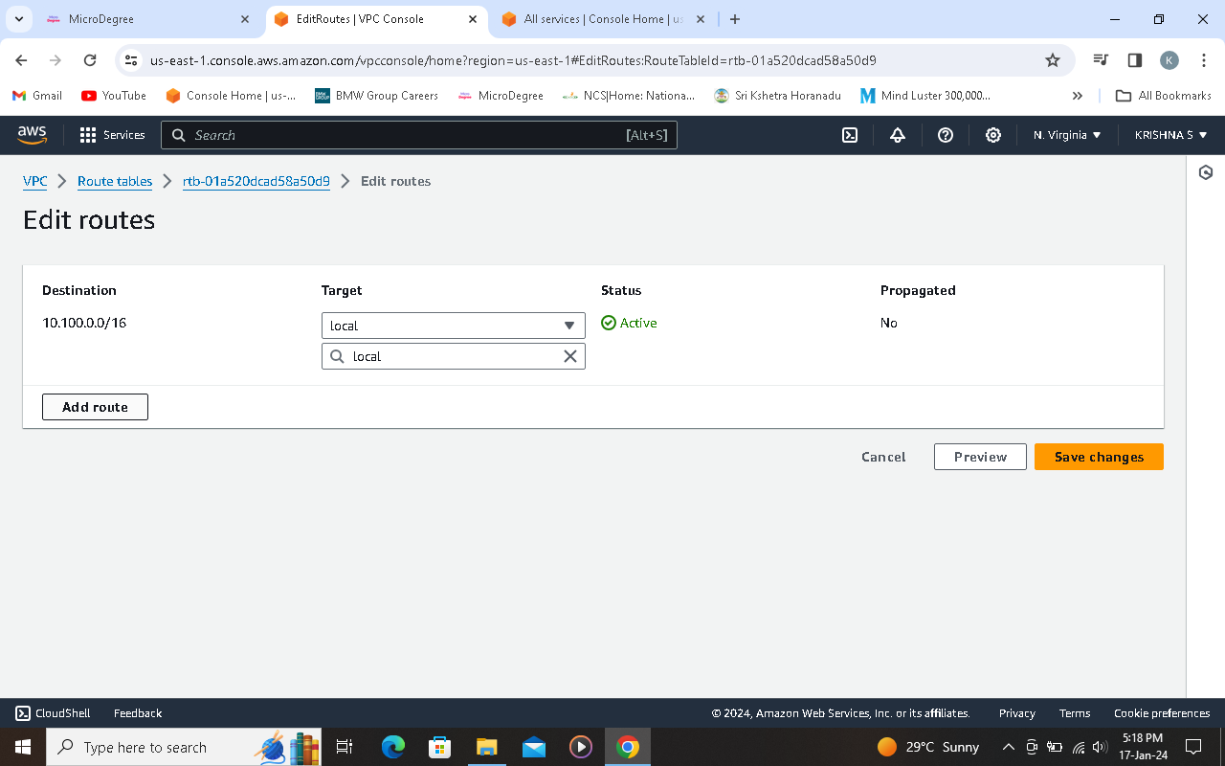

**Step 28 select internet IP address from the destination list**

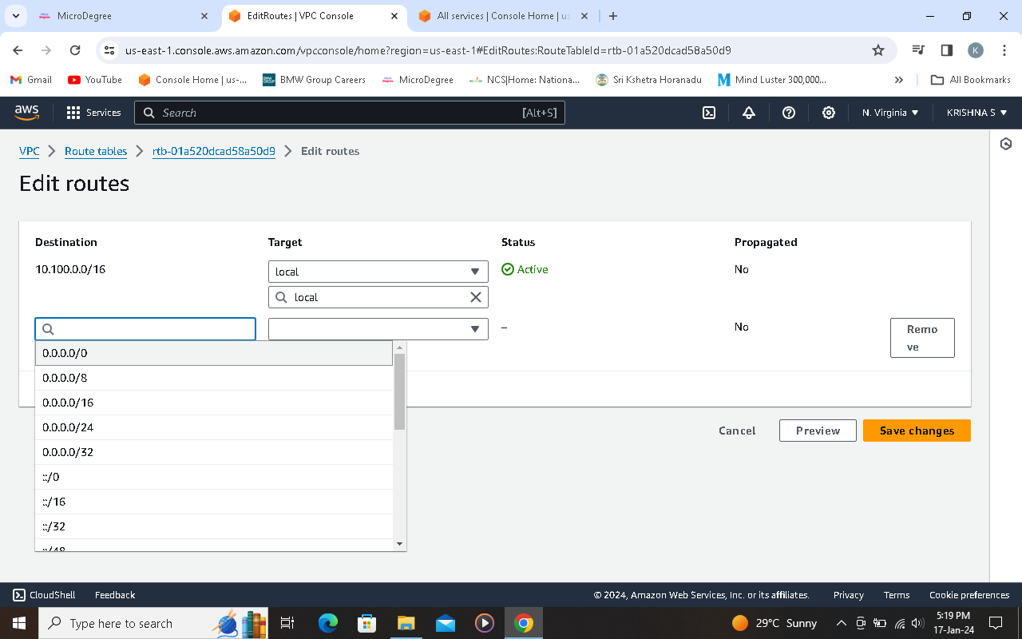

**Step 29 select internet gateway from the target list**

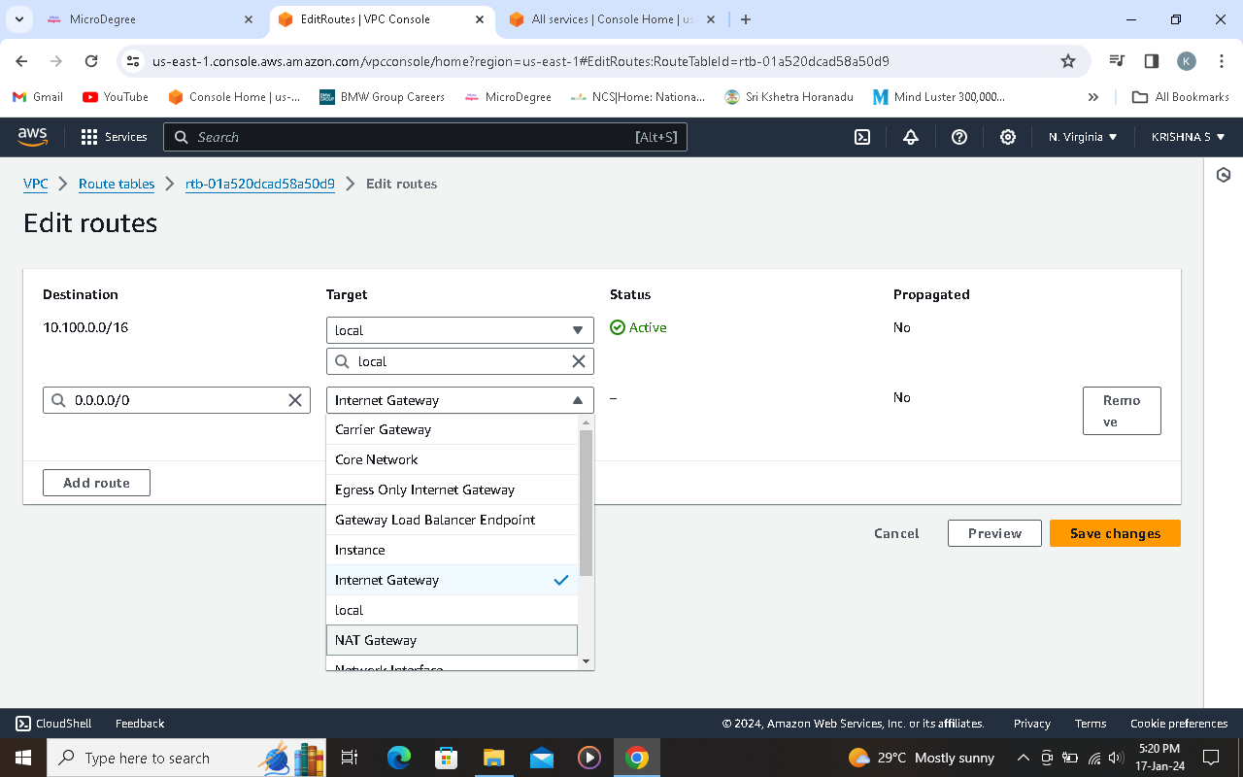

**Step 31 updated route successfully**

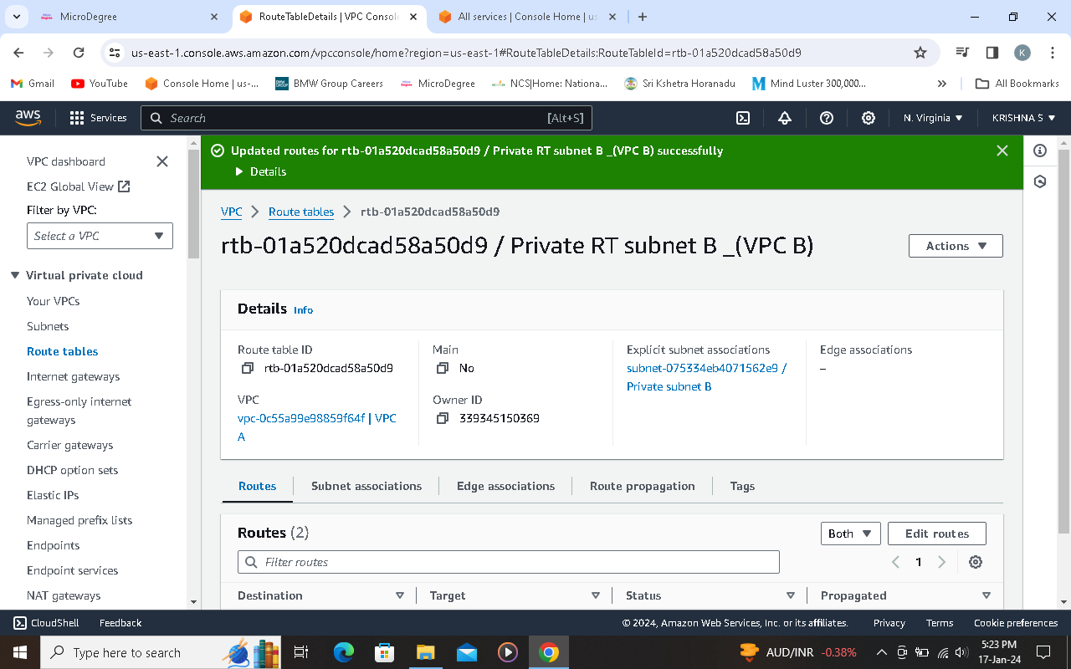

**Step 32 created 2 EC2 instances using new VPC**

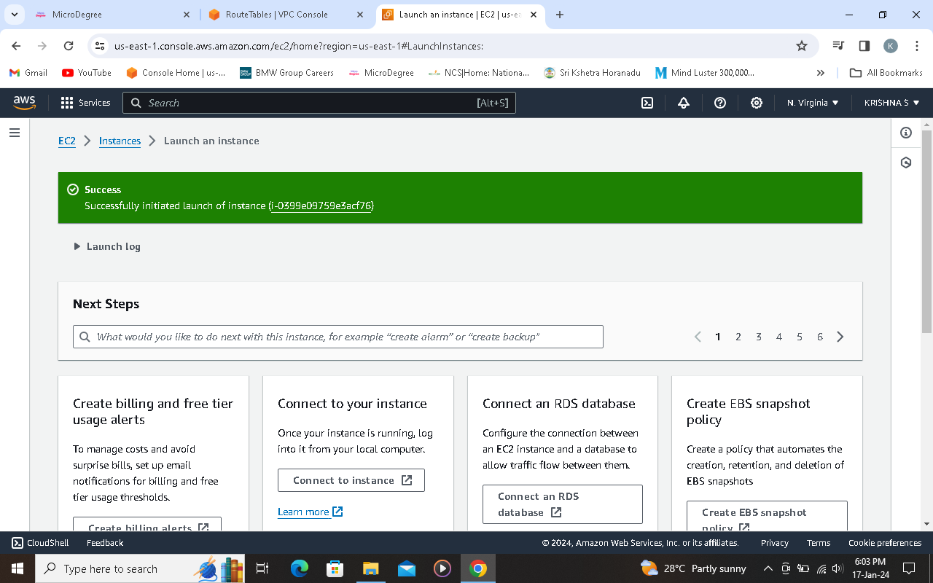

**Step 33 connect to public IP Address using Putty**

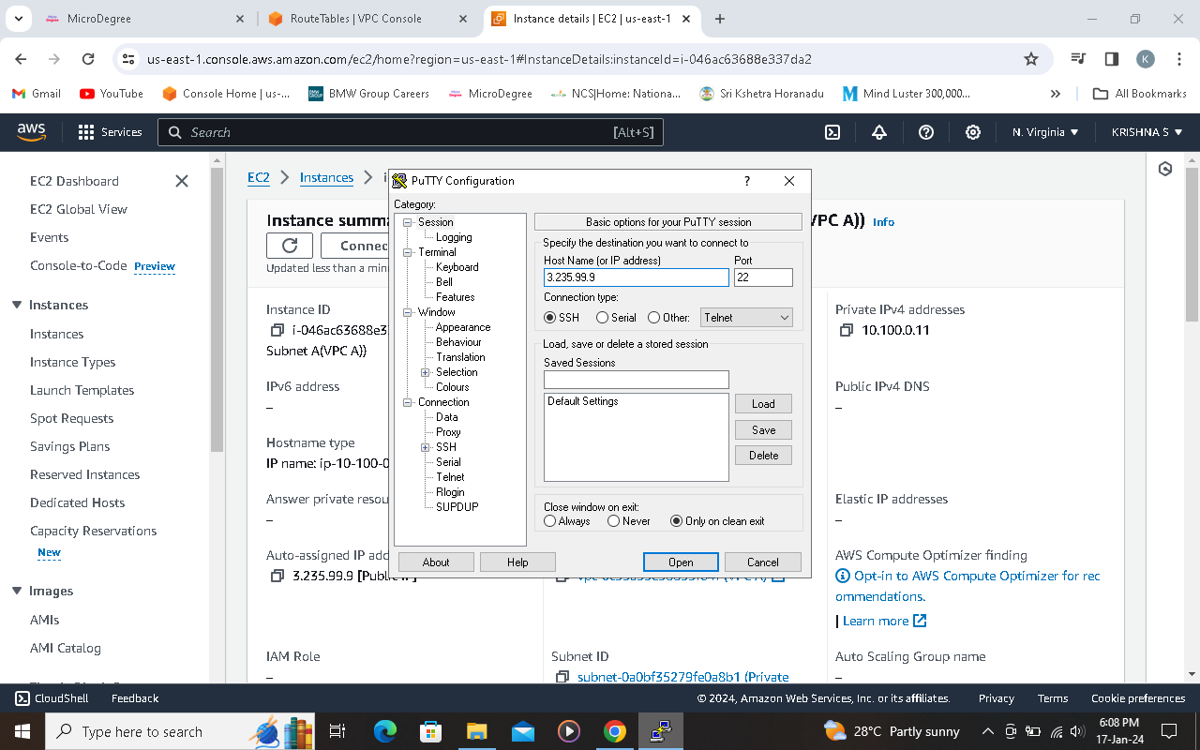

**Step 34 successfully connected**

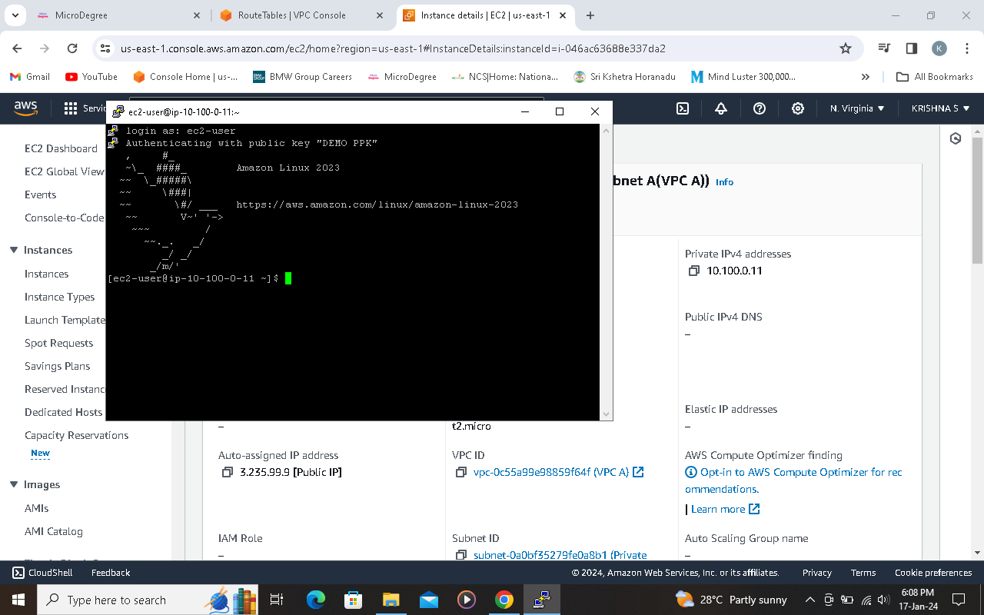

**Step 35 ping to another Private IP**

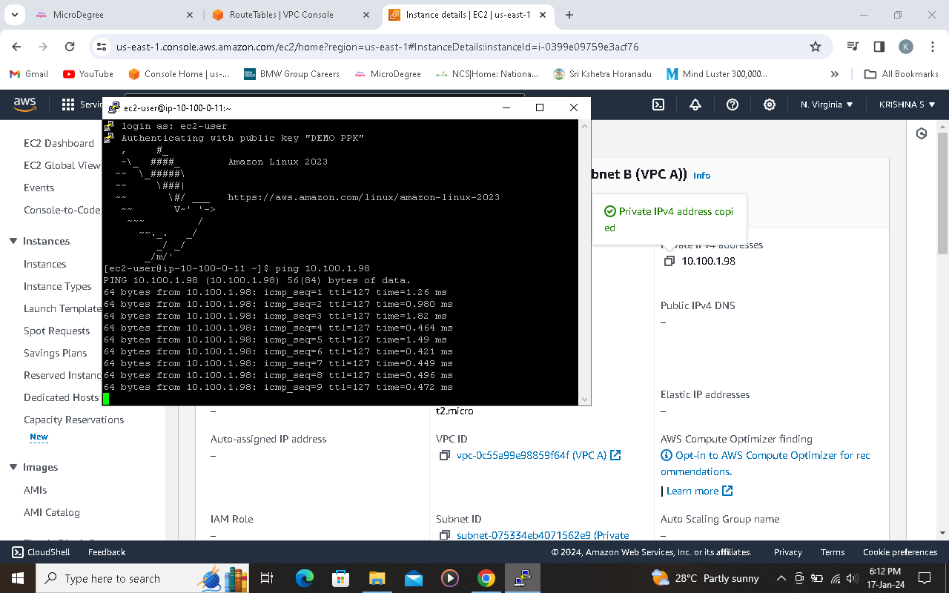

**Step 36 ping to google.com**

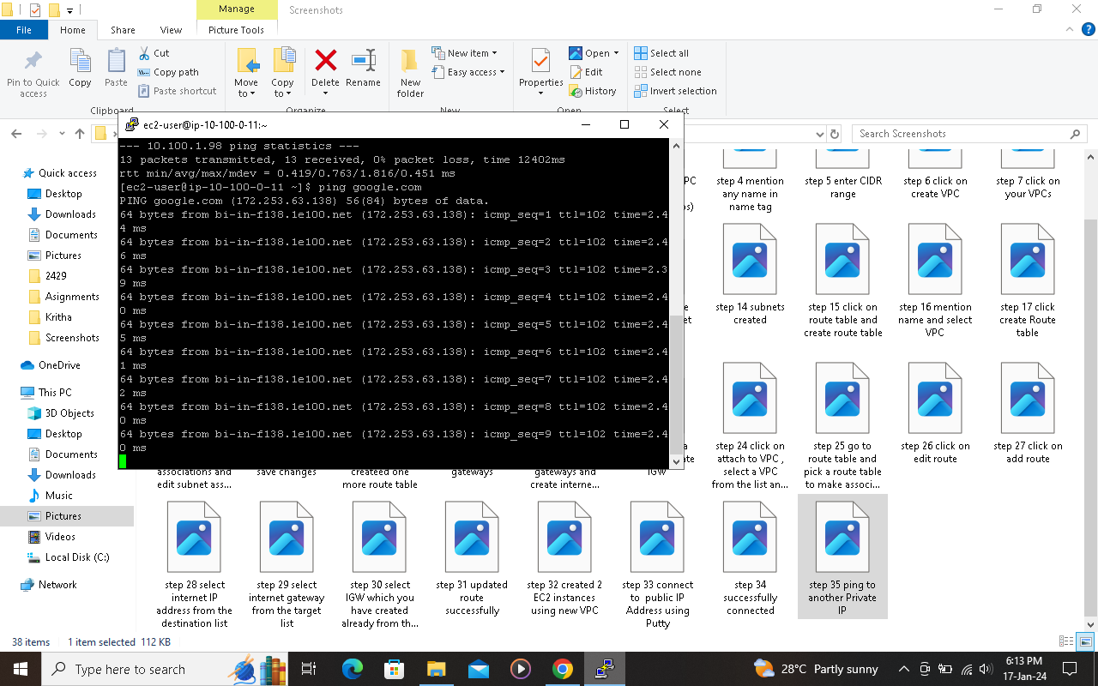

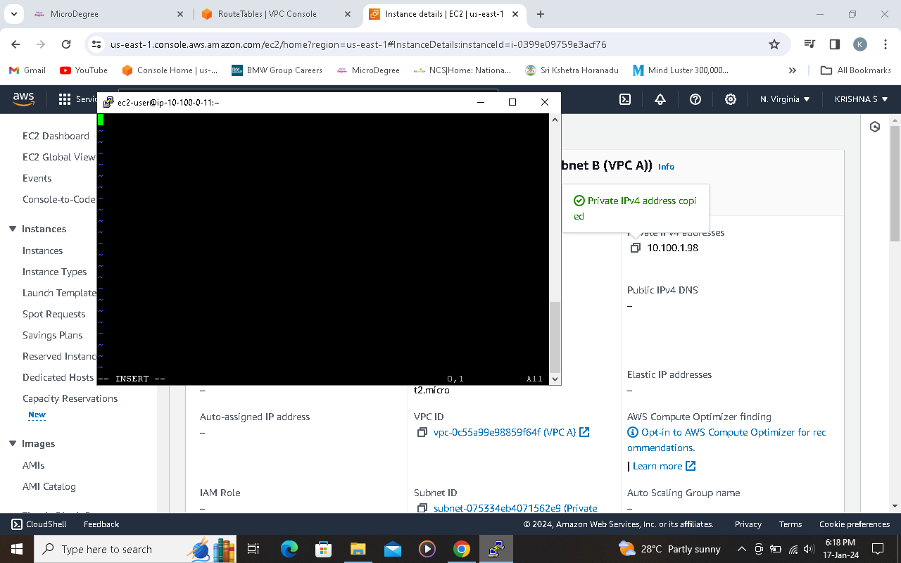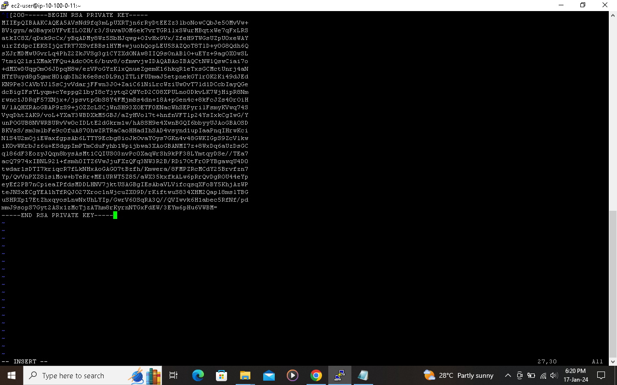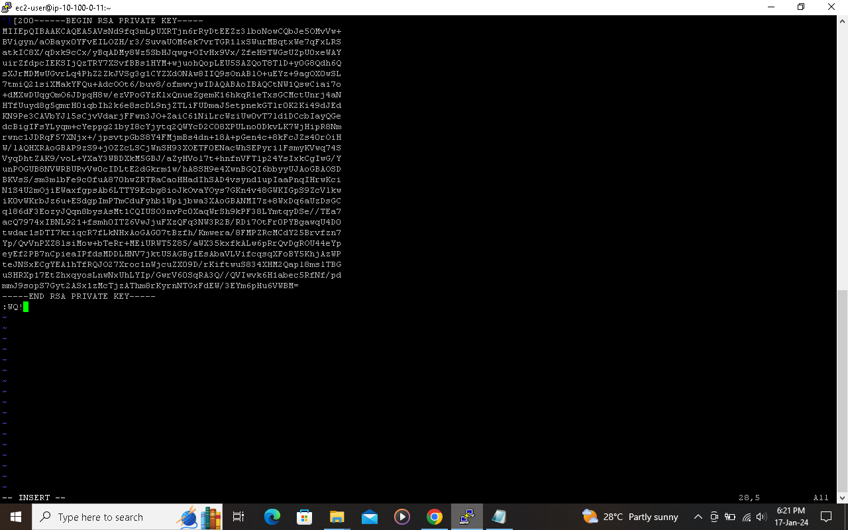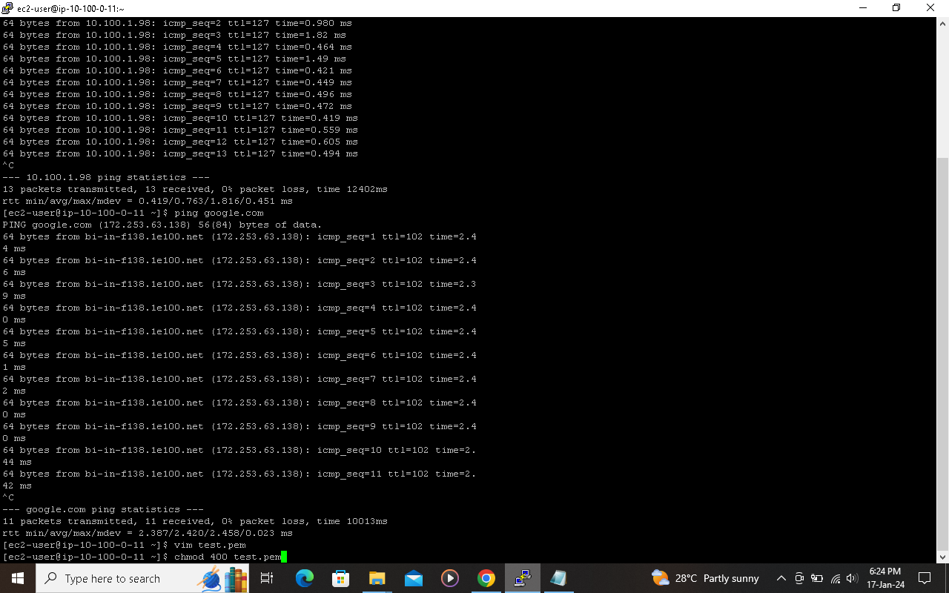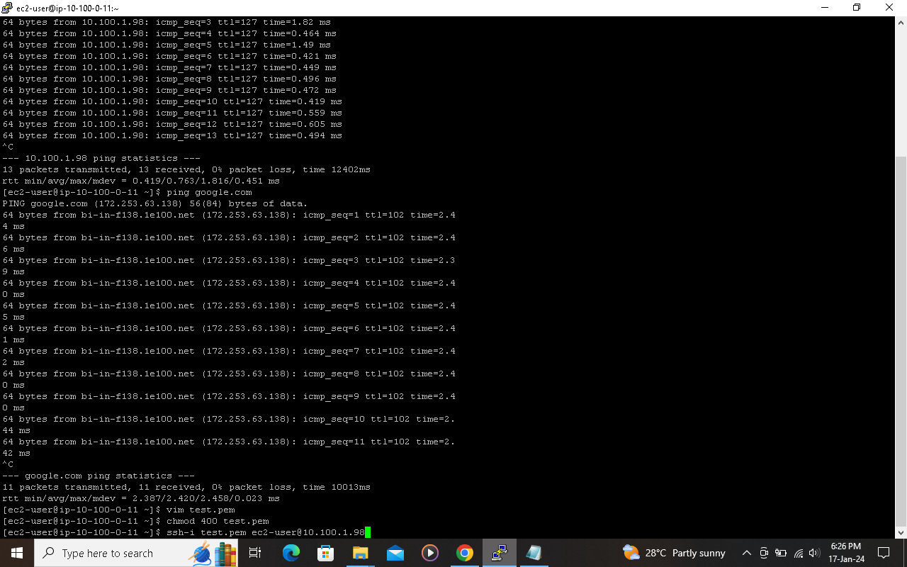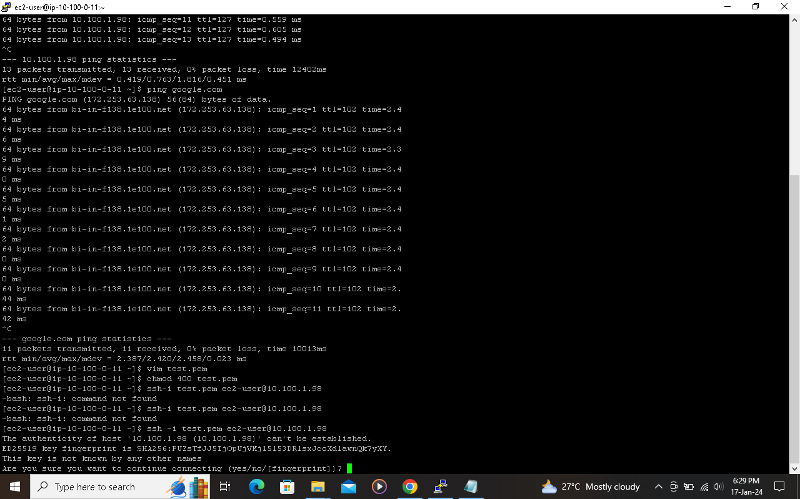



**STEP 43 created VPC B**

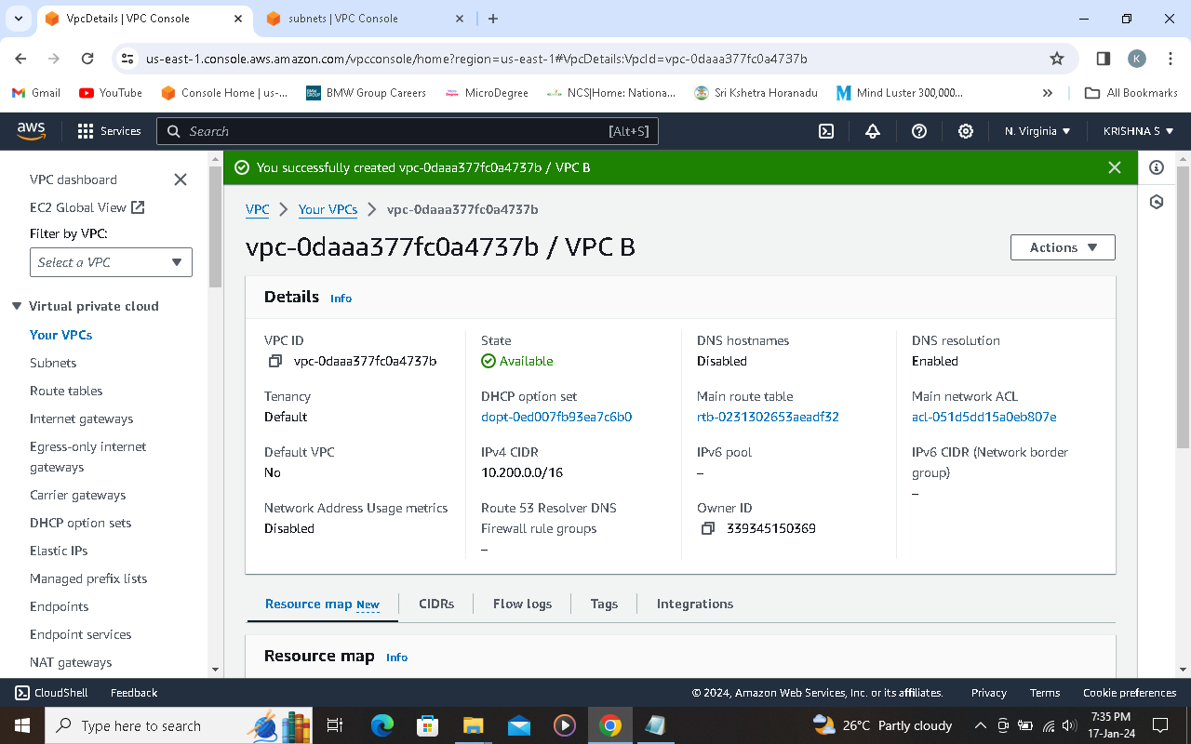

**Step 44 created Private subnet B using VPC B**

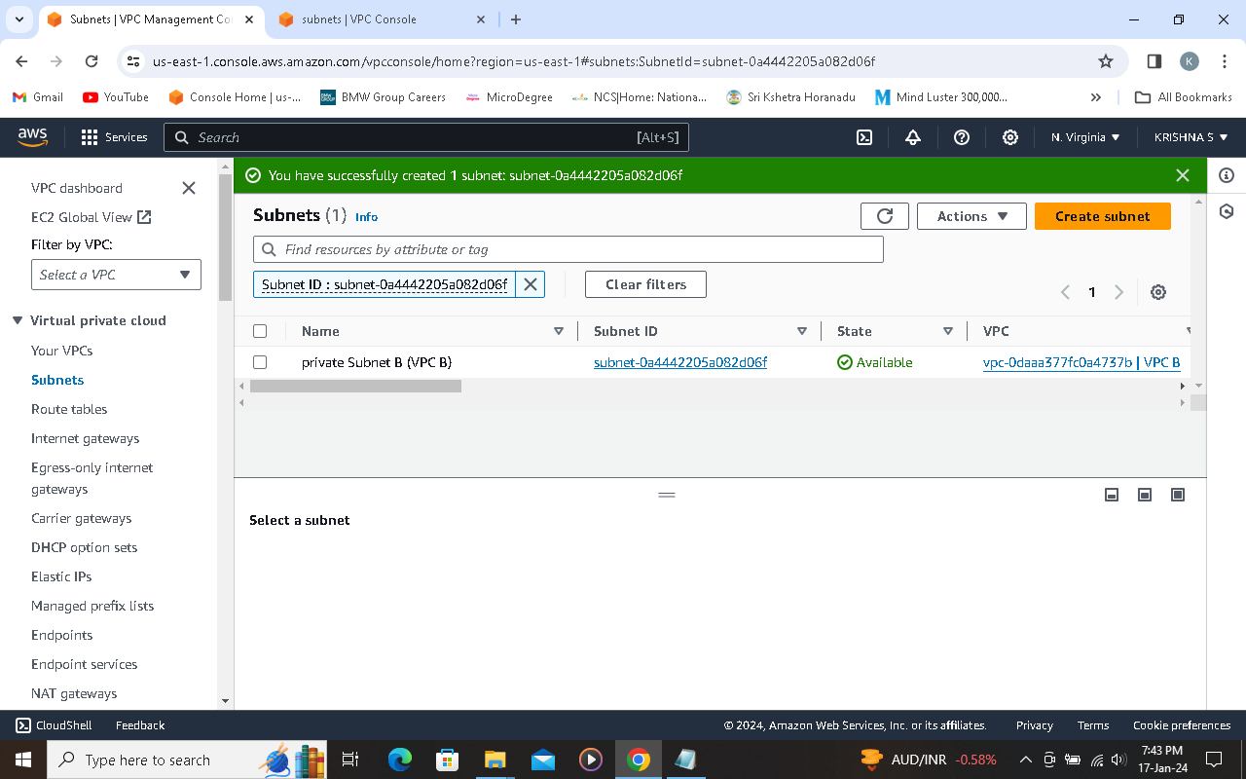

**Step 45 created private RT for VPC B**

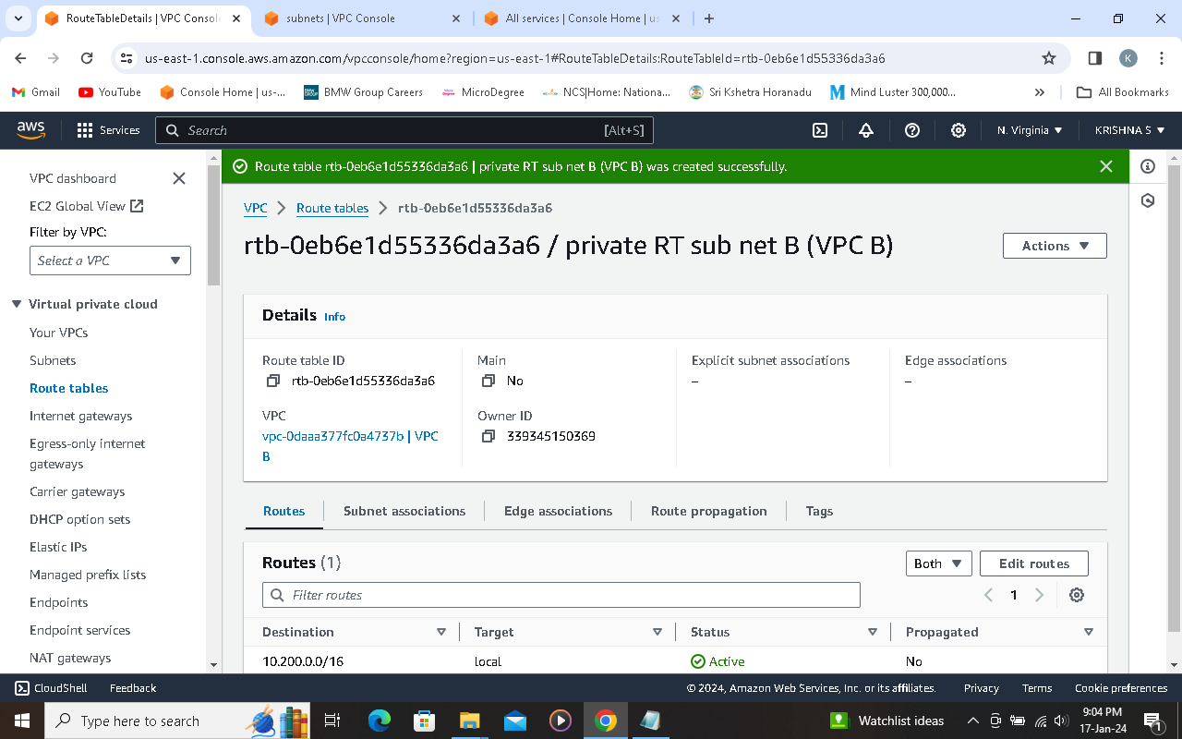

**Step 46 EC2 instance created for VPC B**

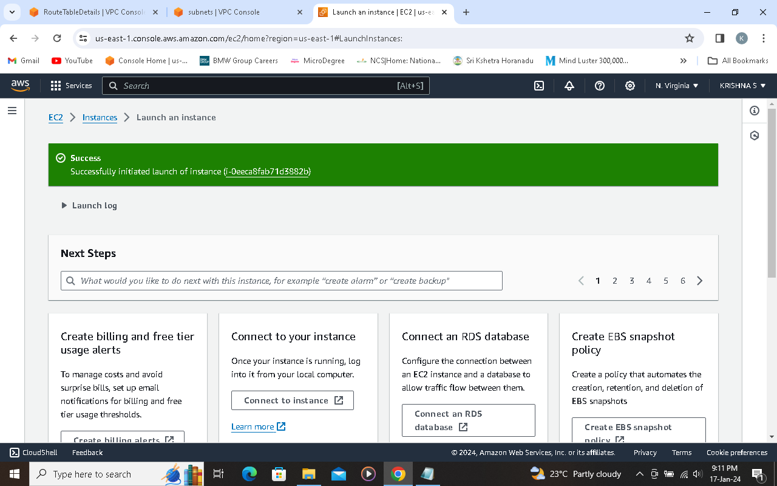

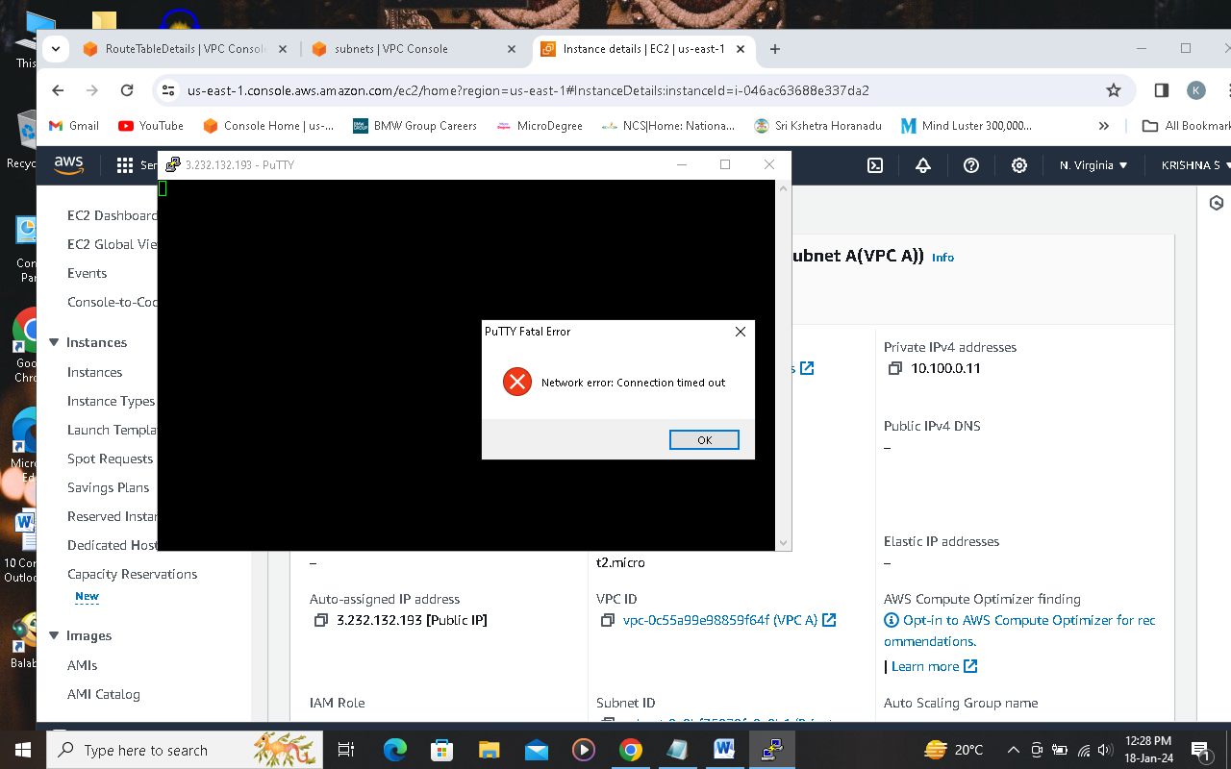

**The above screenshot appeared many time while doing peering, still I am doing in my free time, once it come desired result I will confirm you mam.**